The Lindsays - Beethoven: String Quartets Opp. 130/133 (2001) [SACD]
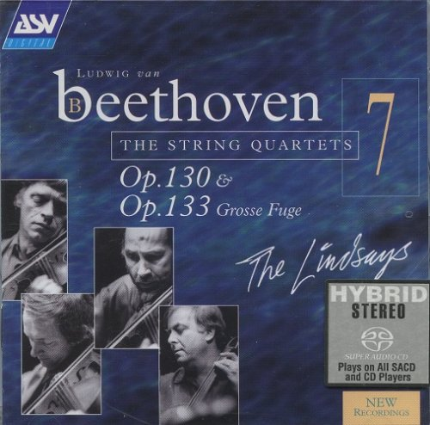

Artist: The Lindsays
Title: Beethoven: String Quartets Opp. 130/133
Year of Release: 2001
Label: ASV [CD DCA 9117]
Genre: Classical
Quality: DSD64 image (*.iso)
Original Recording Format: PCM
Number of channels: 2.0
Total Time: 01:09:15
Total Size: 2,77 GB
WebSite: https://www.discogs.com/Ludwig-van-Beethoven-The-Lindsays-Op-130-Op-133-Grosse-Fugue/release/7542883

Tracks:
String Quartet in B flat, OP.130
01. First Movement Adagio, ma non troppo – Allegro
02. Second Movement Presto
03. Third Movement Andante con moto, ma non troppo
04. Fourth Movement Alla danza tedesca
05. Fifth Movement Cavatina
06. Sixth Movement Grosse Fuge, Op.133
Alternate performance
07. Fifth Movement Cavatina
08. Sixth Movement Finale Allegro
Personnel:
* Peter Cropper (first violin)
* Ronald Birks (second violin)
* Roger Bigley / Robin Ireland (viola)
* Bernard Gregor-Smith (cello)

Reviews:
Review by Julien August 15, 2006 (13 of 16 found this review helpful)
Performance: 5 Sonics: 5
First of all, I'm a cello player, and I know Beethoven quartets quite well, for having played some of them too.
I will start with a few comments on the "controversial" performance of the Lindsays. A funny thing is that I didn't know them well before I bought this recording. I knew the Prazak better, and had the whole Prazak's Beethoven on SACD. I thought, great recording, although it's not my favorite style, but these guys are impressive. But let me tell you something, the Lindsays version talks to me more in every aspect !
I see some people arguing that they play out of tune, well, harmonically speaking, they are nearly never out of tune when the harmony needs it (no one is perfect)! Intonation is a complicated thing, and we string instrument players work on it a lot I believe. The modern piano's twelve-tone equal temperament intonation is not right harmonically, or let's say physically speaking. For example, a fifth on the piano is smaller than it should be, the just intonation will sound a lot richer with much more harmonics. A fourth is bigger than it should be, a major third bigger too, a minor third smaller than it should be, etc.
These are not personal view, just facts anyone who has ears can here if given the occasion. The fact is that we get used to the twelve-tone equal temperament, and seem to believe that it is right. It is not, it is just a practical way of combining all the tonalities together.
Some quartets, like the Alban Berg quartet, play a lot with this kind of intonation. Some don't, like the Lindsays. They are harmonically quite accurate I believe, and sometines what some may call "out of tune" really serves the expression. Listen to Yo-Yo Ma, even Isaac Stern and many more, and you will know what I'm talking about. And as much as I like the Prazak version, Kanka, the cellist of the Prazak, plays too high too often in the lower register, and especially when the harmony needs to be rich ! That is not on purpose, and the problem is that the bass notes are the basis of intonation, so this alters the harmonic richness a lot. And when you add the huge vibrato they all play with, it doesn't always help the richness or homogeneity of the quartet's sound either. But that comment was personal I agree.
Anyway the fact is that it is quite obvious to me that the Lindsays intonation is a lot more controlled than the Prazak's intonation, and as a instrument player I am convinced that they work more on it too.
OK, maybe I'm being boring here. Let me talk a bit about the interpretation. It is just awesome ! So moving from the first note to the last, and anyway my language ability is not good enough to describe it properly. I love it, that's all.
And as for the recording, it is the best string quartet recording I've ever heard. I have had a few different SACD players, speakers, amplifiers, cables etc, and there are many recordings that I hear differently on different equipment, sometimes it gets worse with better equipment, sometines better, sometimes it's completely different. But this recording is a winner, it has always sounded great, you have everything you want to hear, everything you usually hear when the instruments are in front of you. The attack of every note, the crispy sound of all four instruments, the perfect combination between sharp sound and an incredibly generous sound, as if you were close and far at the same time ! The balance is just right too, and I want to add that if you put the Prazak recording after this one you can't help but wondering : do the Prazak play on bad instruments ? Maybe it's just the difference, but the instruments in the Prazak recording don't sound as rich and free.
Anyway, get this recording, listen to it, forget about your habits or preferences, learn to understand their language (you don't see the beauty of foreign poetry if you don't know the language, and I believe it's the same for different styles in different forms of art) and get yourself some hours of happiness or beauty or whatever you want to call it !
By the way, I have now the Cary 306 SACD player, it so lets the music express itself !
See you folks, I hope this review can be helpful.

Review by Beagle August 9, 2005 (10 of 14 found this review helpful)
Performance: 5 Sonics: 4,5
SCENE: You are at a crowded, lively, exciting party; you 'circulate'.... You find yourself in a beautiful room, and say to yourself, 'Ah, this is lovely...'. --And then you notice that no-one else is in that particular room; you get an uneasy feeling bordering on fear...!
Why has this disc remained unreviewed? Is there a body in the closet? I have a theory: judging from discussion here and on other threads, the quartet-buying world is polarised into Lindsay-loving and Lindsay-hating fanatics. Old Joke: a fellow is stopped in the middle of the night in Belfast by a masked gunman, who demands: 'Are ye Catholic, or are ye Protestant?!' The poor fellow sighs, 'Oh my lucky stars, thank god I'm an Athiest!' The gunman brandishes his weapon and demands, 'But, are ye a Catholic or a Protestant Athiest?!'
I shall risk my life here, and be gunned down by one or both sides of this sectarian war. There is a generous amount of opinion documented on this site, that the Lindsays 'play out of tune' (and therefore are sub dig). The opposition party avows, 'True, but they are very expressive'. I don't know how perfect my pitch is, but I hear bad notes often enough to claim that ability. I am listening to the Lindsays right now, and I hear (1) music, (2) expression and (3) something that sticklers might call 'out of tune' but which I identify as 'note-bending' in the interest of expression.
This IS sad, perhaps suicidal-minded* music by a Beethoven who was not having a fun time. Western musical history is the sequential toleration of minor keys, modulation, chromaticism, dissonance, whatever, in the interest of emotional evocation (always against staunch opposition). What is to restrain this genius-madman from writing music so sad it is best played slightly bent? It ISN'T a happy Strauss waltz. If it were perfect-pitched, metronomic, eckt-deutsch, it would be wrong.
I've been listening to the Lindsays do these quartets for 18 years, and I am more and more convinced, as I listen now, that this is an utterly masterful recreation of the music in Ludwig's brain. So shoot me.

