Beethoven - Symphonies No. 4,6
Budapest Festival Orchestra, Ivan Fischer

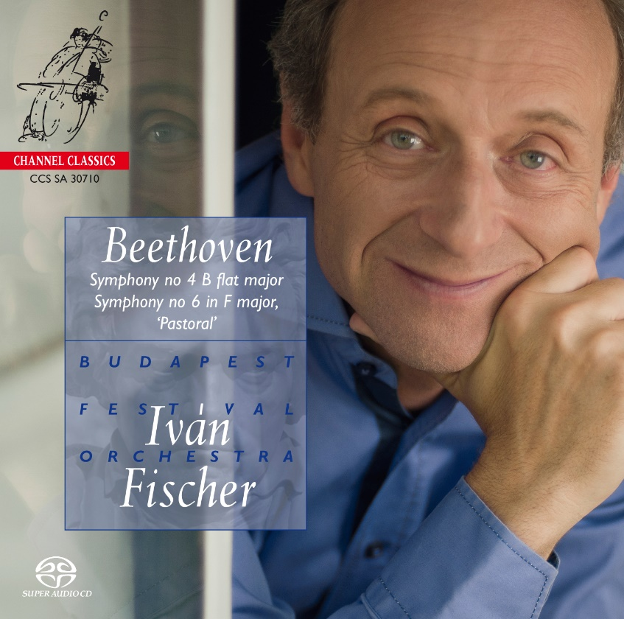

Формат записи/Источник записи: [SACD-R][OF]
Наличие водяных знаков: Нет
Год издания/переиздания диска: 2014
Издатель (лейбл): Channel Classics
Жанр: Classical
Продолжительность: 01:18:28
Наличие сканов в содержимом раздачи: да
Треклист:
1. Symphony no. 4 in B flat major op. 60 - Adagio-Allegro vivace - 11:50
2. Symphony no. 4 in B flat major op. 60 – Adagio - 08:52
3. Symphony no. 4 in B flat major op. 60 - Allegro vivace - 05:49
4. Symphony no. 4 in B flat major op. 60 - Allegro ma non troppo - 06:47
5. Symphony no 6 in F major op. 68 ‘Pastoral’ - Allegro ma non troppo - 11:50
6. Symphony no 6 in F major op. 68 ‘Pastoral’ - Andante molto mosso Szene am Bach - 13:37
7. Symphony no 6 in F major op. 68 ‘Pastoral’ - Allegro Lustiges Zusammensein der Landleute - 05:02
8. Symphony no 6 in F major op. 68 ‘Pastoral’ - Allegro Donner. Sturm - 03:44
9. Symphony no 6 in F major op. 68 ‘Pastoral’ – Allegretto - 10:57

Personnel:
Budapest Festival Orchestra
Ivan Fischer - conductor

Контейнер: ISO (*.iso)
Тип рипа: image
Разрядность: 64 (2,8 MHz/1 Bit)
Формат: DSD
Количество каналов: 2.0, 5.0
Original Recording Format: DSD64
Источник (релизер): WEB.
Beethoven - Symphonies no. 4,6 - NativeDSD Music

Доп. информация:
Label: Channel Classics
SKU 30710
Release Date: January 10, 2014
Recording location: The Palacer of Arts, Budapest, Hungary, 2010
Original Recording Format: DSD64
Recording Type & Bit Rate: DSD64

Об альбоме (сборнике)
Two fundamentally different symphonies: both works explore feelings from an entirely different point of view. The Fourth is about human feelings and moods: obsession, love (what a melody in the second movement!), happiness, fun, wit, (Beethoven’s most humorous finale!). The Sixth is about feelings that nature awakens in us: calmness, meditation, thankfulness. It has been an especially creative process to work on these masterpieces. We discovered that the Fourth Symphony sounds better with natural horns and trumpets. In the Pastorale we used a different seating arrangement, with the winds scattered among the strings, so that each soloist was surrounded by musicians playing the flow of Beethoven’s nature music. After the storm, when we hear the first tentative horn call with a bagpipe-like accompaniment, suggesting signals across the mountains, we found it appropriate to answer with a solo violin, which is gradually joined by the whole orchestra.
Iván Fischer

Reviews:
Opus HD Magazine
Ivan Fischer surprises with a unique inventiveness which at the same time offers a new approach to the symphonic universe of the Bonn master, even if his interpretation follows on from a certain tradition. It's really exciting from start to finish and the airy sound recording perfectly respects this "open" vision with undeniable breath. A success.

Mad.lesoir.be
Each recording of Ivan Fischer and his Budapest Festival Orchestra becomes a makeover for the recorded works. It is this time to the “light” Beethoven of the 4th and 6th symphonies that this rejuvenation is devoted. Very classic in tone but relentless in its rhythmic vigor, the 4th goes straight to the point supported by superb interventions in chiaroscuro of the woods. As for the Pastoral Symphony, the whole orchestra roars there with overflowing vitality, coruscating sounds in a kind of hedonism of nature that warms the heart.

Parool
One of the most beautiful and interesting orchestras of our time. This is primarily due to the Hungarian-Dutch conductor who never ceases to surprise, whatever repertoire he is working on and also the quality of the musicians (…). Even on modern instruments, Fischer gives the notes an unbelievable freshness. Short and sweet: recommended.

www. Opus klassiek
In the Fourth, it has become an Adagio full of unadorned poetry that speaks directly to the heart, with those sublime dialogues between strings and winds that make the heart melt. In the corner parts all noses are perfectly in the same direction, everything is really 'right under each other', it is splashing from the first to the last chord, with an enormous rhythmic drive that almost has that "who is doing me what" gesture. radiates. It is 'power play' of the right kind, the kind of boyish toughness that is contagious (…) The Sixth: it seems as if Fischer and his troops are also right in the middle of it, so convincingly does he convey that unique country life set in music over the spotlight. (…) Jared Sacks and Hein Dekker have again put a lot of work into it in the art palace in Budapest and delivered a beautiful recording, the umpteenth in a row. Highly recommended, this Beethoven duo from the stables of Fischer and his Budapest Festival Orchestra. Is this going to be a Beethoven cycle? Certainly!

Klassieke Zaken
An attractive work that does not have a weak moment. Iván Fischer and his Budapest Festival Orchestra know what to do with the composition in a passionate interpretation that lends the simple melody a great sound beauty. The whimsical, burlesque elements in the Scherzo and the Finale are no less enthusiastically dosed. Fischer is completely above matter. Then the Pastorale comes to life like a great idyll, interrupted only by the thunderous violence of the storm, which comes quickly and just as quickly dissolves in the distance. The conductor provides balanced orchestral groups and, especially in the development of the first movement, surprising counterpoints. The countless recordings of Beethoven's symphonies prove that no conductor can say a definitive last word about them. (…) this new interpretation by Iván Fischer is one of the best of the moment. All praise for the warm, beautiful registration.

Audiophile Audition 5 out of 5
For the performance of the Sixth Symphony, Ivan Fischer changed the orchestra’s seating arrangement, moving the woodwind players among the strings, so that the individual soloists were always surrounded by the flow of Beethoven’s music. The results are spectacular, and the same seating arrangements were employed at the concert series in advance of this recording to much acclaim. (…) (…) this very well might be the best sounding disc of Beethoven (…) I give this disc five stars – it hits on all cylinders, and the performances are every bit the equal of the superb sound. You’ll be hard pressed to find a more emotionally involving, yet technically perfect performance. Very highly recommended sound.

Sa-cd-net
Every new recording project from Ivan Fisher and his marvellous Budapest Festival Orchestra is the product of a combination of the conductor’s profound musicianship and his sense of adventure.(…) Fischer sees Symphony No.4 as a work about human feelings and moods, and he unfailingly communicates the joy and humour in Beethoven’s writing as well as the wonderful lyricism found in the slow movement. (…) In the ‘Pastoral’ Symphony Fischer’s tempi for each of the five movements are particularly well chosen to match the conductor’s carefully considered viewpoint of the work. The outer movements are genial and relaxed, the merrymaking (III) brilliantly bucolic and the storm (IV) suitably thunderous. (…) the wonderful orchestral playing is matched in artistry by the superb 5.0 high-resolution recording made by Jared Sacks and Hein Dekker.

Scottlf. livejournal
If you haven’t discovered the BFO, then may I strongly urge you to bolt to your nearest supplier, be that a record store or Amazon or ArkivMusic or iTunes or Passionato or anybody else who carries Channel Classics, a Rolls-Royce marque amongst record labels. In an era filled with uncertainty, the success of this young orchestra-and its stratospherically-high musical standards—is a delightful thing to behold. (…)
(…) an orchestra that makes magic with tone (…) Beethoven the sensualist, Beethoven the tonal wizard, Beethoven the tone painter. The BFO’s latest release: Beethoven in all his opulent glory.

Classics Today 5 out of 5
These are beautiful performances (…) This ‘Pastoral’ is magnificent, particularly in the first two movements. Fischer pays particular attention to details of string articulation, from the elegantly sculpted bass lines up. The result is amazingly transparent (the winds are positioned within the string section), fresh, and vital, but also rich-toned. (…) Fischer continues to sustain his reputation as one of the finest conductors around in any repertoire.

The Times
the bubbling energy are among the winning attributes of Fischer’s performances, with his Budapest Festival Orchestra. Plus, a little presumption: ignoring the score, Fischer launches the sixth’s finale with a solo violin (…)

The Independent
The strings are plumper than we’ve come to expect from recent Beethoven cycles but the Budapest Festival Orchestra can still deliver at the composer’s original metronome markings. Conductor Iván Fischer only invokes fevered revolution at certain moments and elsewhere concentrates on well-argued phrases and a general sense of wonderment. Woodwind and brass detailing is excellent throughout, while the sublime close leaves you itching to hear Fischer’s Seventh.

Classic FM Magazine
it gets better and better: there’s a beautiful singing quality to the Adagio, and the neat, pointed performance of the last movement is all you could wish for.

Hi-Fi
These are among the finest recorded and perfpormed works I’ve ever heard (…) not to be missed and to be placed with your reference performances.

American Record Guide
Comfy, well-upholstered, smpoothly played accounts of Beethoven’s sunniest, happiest symphonies. (…) Fischer’s accounts feel positively expansive. (…) clean, warm performances in probably the best high-resolution digital audio.

BBC Music Magazine
Hypnotically homogeneous of timbre, hushed and soft-focused. (…) The playing of the Budapest Festival Orchestra, beautifully recorded, is as glowing as ever, and the fourth is particularly fine, with an admirably warm account of the slow movement…

Fanfare
In the performance of the Fourth Symphony, Fischer captures all of the variety of mood – mystery, melancholy, swagger, and humor – that this fascinating score can project. There is real joy in this music, and Fischer and his orchestra revel in it; (…) It is unusual, to say the least, to find a disc that sounds this fresh in repertoire this familiar, but Fischer and his Budapest band have a knack for doing just that.

www.positive-feedback.com
This version has everything I ever wanted in a ‘Pastorale’, with some of the finest sound I have ever heard.

