Brahms - Symphony No. 1 in C minor Op. 68, Variations on a Theme by Joseph Haydn Op. 56a, Hungarian Dance No. 14 (arr. Fischer)
Budapest Festival Orchestra
Iván Fischer (conductor)

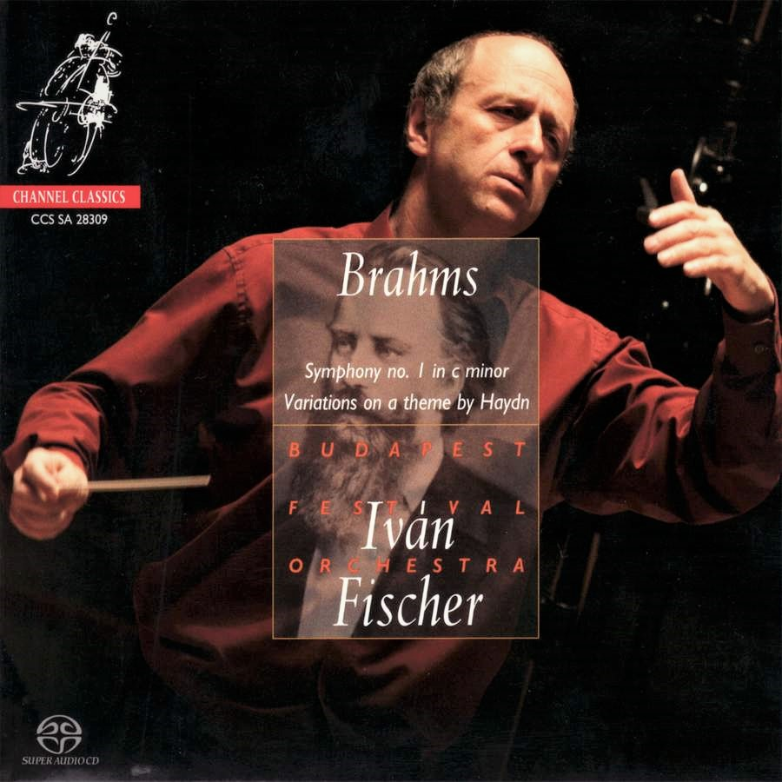

Формат записи/Источник записи: [SACD-R][OF]
Наличие водяных знаков: Нет
Год издания/переиздания диска: 2009
Издатель (лейбл): Channel Classics CCS SA 28309
Жанр: Classical
Продолжительность: 01:07:00
Наличие сканов в содержимом раздачи:
Треклист:
01 - Hungarian Dance No.14 in D minor - 2:35

Variations on a theme by Haydn for orchestra, Op. 56a 'St Anthony Variations'
02 - Thema, Chorale St. Antoni, Andante - 2:04
03 - Variation 1, Poco più animato (Andante con moto) - 1:12
04 - Variation 2, Più vivace (Vivace) - 1:00
05 - Variation 3, Con moto - 1:41
06 - Variation 4 Andante con moto (Andante) - 1:44
07 - Variation 5 Vivace (Poco presto) - 1:00
08 - Variation 6, Vivace - 1:18
09 - Variation 7, Grazioso - 3:00
10 - Variation 8, Presto non troppo (Poco presto) - 1:02
11 - Finale, Andante - 3:55

Symphony No. 1 in C minor, Op. 68
12 - I. Un poco sostenuto – Allegro - 16:25
13 - II. Andante Sostenuto - 8:47
14 - III. Un poco allegretto grazioso - 4:33
15 - IV. Adagio - Allegro non troppo ma con brio - 16:55

Personnel:
Budapest Festival Orchestra
Iván Fischer (conductor)

Контейнер: ISO (*.iso)
Тип рипа: image
Разрядность: 64 (2,8 MHz/1 Bit)
Формат: DSD
Количество каналов: 2.0, 5.0
Original Recording Format: DSD64
Источник (релизер): WEB.
HRAudio.net - Brahms: Symphony No. 1 - Fischer

Доп. информация:
Release Date: 28th Sep 2009
Catalogue No: CCSSA28309
Label: Channel

Об альбоме (сборнике)
Ivan Fischer tunrs his attention to Brahms following three acclaimed and Award-winning recordings of Mahler.
Stunning interpretation of Brahms Symphony No.1 – once again Ivan Fisher forces the the listener to re-appraise familiar repertoire.
“An orchestra musician is an artist, not an employee, and artists must be given the chance to take initiatives and to be creative. Only an orchestra of true artists – making music as a highly disciplined team - is able to realize the dreams of the composers and pass on an uplifting experience to the audience, touching all listeners deep in their heart. This is our aim for which the Budapest Festival Orchestra has been created.” Iván Fischer

Reviews:
Brahms: Symphony No. 1, etc./Fischer SACD
Review by: David Hurwitz
Artistic Quality: 10, Sound Quality: 10
Iván Fischer and his orchestra hit the ball out of the park with this recording, offering a First Symphony full of personality and fire, all at an exalted technical and interpretive level. Indeed, on the basis of this recording I would rank Fischer as one of the truly great conductors now active, not just because he justifies yet another recording of this ubiquitous warhorse, but because of his achievement in creating an orchestra whose sound is as characterful as his performances. Just listen to the playing of the strings in Fischer’s own arrangement of the Fourteenth Hungarian Dance–it’s a rich, voluptuous, but also rhythmically acute and somehow very Hungarian sound, the kind of passionate spontaneity we used to hear from colleagues such as Fricsay or Sándor Végh, and these qualities typify the entire disc.
The opening of the First Symphony sets the stage for a performance like no other. With generous (but never vulgar) string portamentos, the entire introduction proceeds in two huge arches, phrased as a real melody. It’s less strenuous and granitic then some (think Klemperer), but just as powerful in its own way. More to the point, after an amazingly detailed and exciting allegro, Fischer lets the trumpets and drums rip in the lead-in to the recapitulation, and times the moment of arrival as well as anyone ever has. It’s simply masterful. The finale also captures exactly the right combination of majesty and joy, and Fischer’s ability to vary the tempo over a wide range without ever breaking the long line is extremely impressive, and genuinely “Romantic”. The inner movements, flowing, lyrical, and fresh, set the seal on a truly great performance from first note to last.
The Haydn Variations reveal exactly the same virtues evident in the other pieces here, so there’s no need to go into the performance in great detail, save to acknowledge the orchestra’s excellent wind section and Fischer’s inevitable and imposing buildup of the concluding passacaglia. As usual, the sonics in all formats–stereo, SACD two- and multi-channel–are stunning, offering an ideal combination of clarity (listen to the the soft timpani and lucid bass lines) and warmth. Even if you have a hundred recordings of this music, let this disc be your hundred and first. [11/3/2009]

BBC Music Magazine
Christmas 2009
This beautifully recorded CD gets off to an auspicious start with an exquisitely phrased and subtly controlled account of Brahms's 14th Hungarian Dance… The Haydn Variations… sounds particularly satisfying here… Fischer secures clarity of texture throughout without sacrificing any warmth. Fischer opens the First Symphony in a very striking but undeniably effective manner, the strings tracing the soaring chromatic melody with the same portamento rich sonority as in the Hungarian Dance. ...perhaps the most exciting and riveting playing is reserved for the Finale where Fischer shows an unerring sense of pacing, coaxing the musical argument from the depths of despair in the opening to triumph, affirmation and elation at the close.
5 out of 5 stars

Classic FM Magazine
April 2011
Ivan Fischer's recording is a real joy: Classical-style limpid textures, an all-round more sprightly attack, yet still a warmly Romantic sound.

Gramophone Magazine
December 2009
Fischer and his decidedly classy Budapest orchestra treat the Variations as an affectionate tribute to Haydn, an east-of-Vienna man if ever there was one. Finely sprung and nicely styled, the performance even has its own zigeunerisch dimension - in the finale where Brahms's witty and heroic use of the triangle is neatly pointed. the symphony... too is a vibrant affair, stylish and alert... This is a more extrovert reading than many you will hear, less burdened.

The Guardian
9th October 2009
Ever the radical, [Fischer] effectively refashions each work from scratch. The Haydn ­Variations have a grace and lightness of touch we don't often hear in them. The First, meanwhile, is monumental in every sense of the word...Outstanding.

