Couperin: Lecons de tenebres
La Sfera Armoniosa
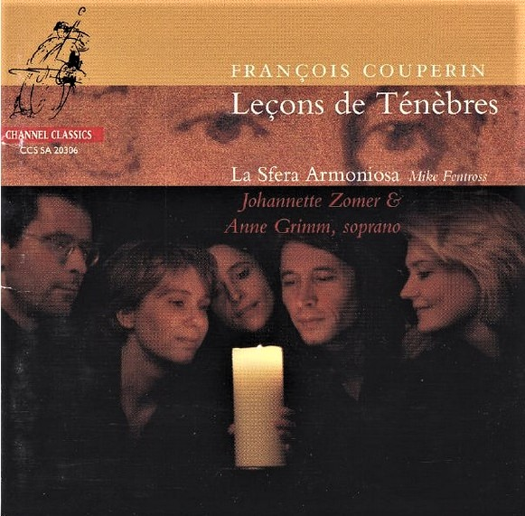

Формат записи/Источник записи: [SACD-R][OF]
Наличие водяных знаков: Нет
Год издания/переиздания диска: 2006
Издатель (лейбл): Channel Classics
Жанр: Classical/ Vocal
Продолжительность: 01:01:07
Наличие сканов в содержимом раздачи: Только обложка альбома

Треклист:
François Couperin (1668-1733)
1. Première Leçon de Ténèbres Pour Le Mercredi Saint à Une Voix: Incipit Lamentatio - Aleph - Beth - Ghimel - Daleth - He – Jerusalem - 20:27
Marin Marais (1656 -1728)
2. Les Voix Humaines - 4:25
François Couperin
3. Deuxième Leçon de Ténèbres Pour Le Mercredi Saint à Une Voix: Vav - Zain - Heth - Teth – Jerusalem - 15:35
Robert De Visee (C.1655 -1732)
4. Les Sylvains de Mr. Couperin - 6:08
François Couperin
5. Troisième Leçon de Ténèbres Pour Le Mercredi Saint à Une Voix: Yod - Caph - Lamed - Mem - Nun – Jerusalem - 14:06

Personnel:
La Sfera Armoniosa:
Johannette Zomer, Anne Grimm (soprano)
Paulina van Laarhoven (viola da gamba)
Mike Fentross (theorbo)
Menno van Delft (organ)
Контейнер: ISO (*.iso)
Тип рипа: image
Разрядность: 64 (2,8 MHz/1 Bit)
Формат: DST64
Количество каналов: 2.0, 5.0
Original Recording Format: PCM
Источник (релизер): WEB.
SA-CD.net - Couperin: Leçons de ténèbres - La Sfera Armoniosa

Доп. информация:
Label: Channel Classics
CCS SA 20306
Release Date: May 9, 2006
Original Recording Format: PCM
Recording Type & Bit Rate: DSD64

Об альбоме (сборнике)
François Couperin's Leçons de Ténèbres, set to the Lamentations of Jeremiah and intended for use on Thursday of Holy Week (they may have been part of a larger set, now lost), would seem on cursory hearing to be light-years removed from his glittering keyboard works, so redolent of the hothouse atmosphere of the French court. Listen again, however, and you find connections: Couperin transfers his uncanny way of making an ornament hang in the air to these deeply serious, arioso settings of the Lamentations for one or two voices, plus continuo. The mood is somber, exploding periodically into more intense expressions of sadness. Dutch sopranos Johannette Zomer and Anne Grimm are early music specialists whose voices are quite complementary to one another. They sing quietly, with little vibrato, hanging slightly on the flat side of the pitch -- appropriate for these chamber-sized and personal works, with their mixture of piety and emotion that pops out toward the end of a phrase. But give a listen to their voices to make sure you're on board with the sound; it's unusual for those who haven't heard much Baroque singing. The accompaniment by La Sfera Armoniosa is dominated by an organ, with subtle contributions from theorbo and gamba -- a beautiful effect. The three Leçons, quite intense if you get into them, are broken up by instrumental works by Marin Marais and lutenist Robert de Visée. The sound of this Channel Classics release is a bit claustrophobic, but that fits the music in a way ... this disc is not for everyone, but listeners from the strongly reverential admirer of sacred music to French Baroque fans should investigate it.

Review:
Couperin: Lecons de Tenebres / Grimm, Zomer
Review by: David Vernier - www.classicstoday.com
Artistic Quality: 10, Sound Quality: 10
Soprano Anne Grimm is a wonderful singer, with a lovely, warm voice, accurate intonation, and an expressive technique that perfectly captures the mood and meaning of these laments, extended songs that require exceptional sensitivity and subtlety. Her sense of phrasing, her delicate use of ornaments, and her thoughtful gradations of dynamics and articulation, so important in this music, keep us attentive to Couperin’s beautiful melodies and artfully integrated texts. And Johannette Zomer, who has displayed a tendency toward hard and even shrill tone in some past outings, shows little of that here. In fact, she uses her bright timbre quite effectively, even though her solo movement–the Deuxième Leçon de Ténèbres–is not quite as musically compelling as the Première Leçon sung by Grimm. Their Troisième Leçon duet shows two singers with agreeably different timbres but one interpretive voice–and the effect of their performance is one of those uniquely communicative moments where the spiritual and artistic worlds make a happy meeting.
Although nothing is mentioned in the notes, the singers employ a French pronunciation of the Latin, a striking and unusual sound for listeners used to hearing the more common Roman Church or German or even Anglican Latin in vocal performances.
The instrumentalists also must receive kudos for their various expert contributions, from accompaniments of the voices (Mike Fentross’ theorbo is particularly eloquent) to their separate offerings of Marin Marais’ Les voix Humaines (gambist Paulina van Laarhoven deserves a whole disc to herself!) and Robert de Visée’s lute transcription of Couperin’s keyboard work Les Sylvains.
The programming, which places the instrumental pieces (both of which are contemporary to Couperin) in between the three Leçons, also shows something of the thought and care that went into its design. And of course, Channel Classics maintains its customary high sonic standard (I listened on a regular CD system, not SACD-surround) making this a highly recommendable presentation of some rare and challenging repertoire. [6/9/2006]

Review by andrewb June 8, 2006
Performance: 5, Sonics: 5
This is an excellent disc, the music is very fine and the performance superb, and the recording still very good, despite the loss of the original DSD master (see the forum discussion about this disc for details concerning the loss of the DSD master).
The Three Lecons of Couperin are separated on this recording by two lute and viol pieces by Marin Marais and Robert de Visee and these make ideal interludes between the vocal music, allowing one to listen through at a single sitting without tiring of the same musical style.
Anne Grimm performs the first Lecon while Johanette Zomer sings the second, of these two sopranos, Grimm has a lower centre to her voice when compared to Zomer but her performance is exquisite, she colours and shades the lines with great delicacy and gives a radiantly intense performance. Zomer is equally fine, though at a noticeably higher pitch than Grimm, but then I have come to expect no less from her after listening to her other marvellous discs on Channel Classics. The instrumental playing is very good and well balanced with the singing.
Recorded in a church the acoustics are excellent, with only slight reverberation, but there is sometimes a faint hum in the background, perhaps noise from some of the recording equipment, but this does not bother one. Apart from this minor defect, the recorded sound is very fine, comparing the multi-channel layer to the CD layer, it is noticeable clearer, more detailed and more delicate. Despite the loss of the original DSD recording for this work, and hence the fact that this recording was produced from a PCM backup with the two rear channels being produced by sound processing, I am very glad that Channel Classics chose to release it on SACD, so allowing us the best possible sound in the circumstances, it is much better than the CD.
As I have said, I was very happy with the sound quality and still am, but out of interest I also sampled similar discs from Channel Classics, such as Splendore di Roma CCS SA19903 , Caccini CCS SA21305 and Death and Devotion CCS SA20804, and there I found that these DSD recorded discs did have more definition and an extra level of clarity and detail when compared to this PCM recorded disc.
In summary, it unfortunate that the DSD recording was lost, but this should not stop people buying this SACD, thankfully the PCM backup has allowed us to hear this marvellous performance in still very good quality sound.

