Debussy - Chamber music
Prazak Quartet, Kinsky Trio Prague

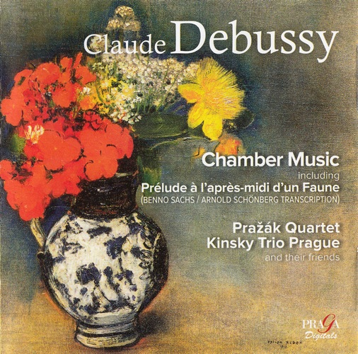

Формат записи/Источник записи: [SACD-R][OF]
Наличие водяных знаков: Нет
Год издания/переиздания диска: 2014
Издатель (лейбл): PRAGA Digitals
Жанр: Classical
Продолжительность: 01:03:48
Наличие сканов в содержимом раздачи: Только обложка альбома
Треклист:
1. Prélude à L'après-midi D'un Faune - 10:12
Sonata for Cello and Piano in D Minor
2. Prologue: Lent, Sostenuto E Molto Risoluto - 4:33
3. Sérénade: Modérément Animé - 3:19
4. Finale: Animé, Léger Et Nerveux - 3:47
5. Rêverie - 4:47
Sonata for Violin and Piano in G Minor
6. Allegro Vivo - 4:48
7. Intermède: Fantastique Et Léger - 3:58
8. Finale: Très Animé - 4:39
9. La Fille Aux Cheveux de Lin - 2:39
Trio No.1 in G Major for Piano, Violin and Cello
10. Andantino Con Moto Allegro - 8:21
11. Scherzo: Moderato Con Allegro - 3:11
12. Andante Espressivo - 3:54
13. Finale: Appassionato - 5:49

Personnel:
Prazak Quartet, Kinsky Trio Prague
and friends
Контейнер: ISO (*.iso)
Тип рипа: image
Разрядность: 64 (2,8 MHz/1 Bit)
Формат: DSD
Количество каналов: 2.0, 5.1
Original Recording Format: DSD64
Источник (релизер): WEB.
SA-CD.net - Debussy: Chamber music - Prazak Quartet, Kinsky Trio Prague

Доп. информация:
Label: PRAGA Digitals
PRD/DSD 250 302
Release Date: April 8, 2014
Recording Location: Domovina Studio, Prague 12/14 June 2013
Original Recording Format: DSD64
Recording Type & Bit Rate: DSD64

Об альбоме (сборнике)
Better known for his works for orchestra or solo piano, Claude Debussy also composed a wealth of beautiful chamber music. This disc featuring the Prazák Quartet and the Kinsky Trio Prague (and invited guests) offers a selection of six works, ranging from the Piano Trio No.1 of 1879, via a fascinating chamber arrangement of the always popular 'Prélude à l'après-midi d'un Faune' to his last work, the Cello Sonata written in 1915. This audiophile quality multi-channel SACD presents these works a unique coupling, not featured on any other disc.
Review:
Audiophile Audition
I have always adored all Debussy. With his trademark whole-tone shimmering harmonies and delicate, transparent instrumentations and what has become such a “French” sound, what’s not to like?
This wonderful collection is of some of his best-known chamber music and a couple of wonderful transcriptions. In the latter category, the opening Prélude to the Afternoon of a Faun is one of his best-known works. For many, it serves as “the” work to introduce music students to Impressionism and to Debussy, specifically. This chamber rendition by Benno Sachs, a student of Schoenberg’s, is beautifully played and the addition of piano and the very unusual addition of harmonium (which can sound deceptively like a saxophone) actually gives the masterwork a new and wholly attractive sound. The great French cellist, Pierre Fournier, transcribed the Rêverie for solo piano for cello and piano and, here too, this works beautifully.
Debussy’s well known piano prelude, Girl with the Flaxen Hair, gets a lovely treatment as well in the transcription for violin and piano by the great Jascha Heifetz.
Debussy’s two Sonatas included here and the somewhat obscure Trio in G major are all wonderful works and performed here with an authentic and clear sound. The Cello Sonata in D-minor was written in 1915 and echoes some of the composer’s early works and the sense of the Baroque he employed in his Suite Bergamasque. I am particularly fond of the central Serenade. The Violin Sonata in G-minor was written shortly after the Cello Sonata and is characterized by a darker, more pensive tone than much Debussy owing, perhaps, to the composer’s battle with cancer.
For me, I found the Trio in G a real find. This was, apparently, Debussy’s only Piano Trio and was written well ahead of many of his much more famous masterworks, in the fall of 1879. Only in 1986 did all three movements get rediscovered, a small section reconstructed and then published. This is a charming work, buoyant and pleasant throughout. However, I agree with the booklet notes that this work may not be immediately recognizable as Debussy. Being an early work, it could be misconstrued as Franck or Lalo. (I heard even some of what could be early D’Indy; whose music calls upon all of these, anyway)
All performances in this set are top notch. The Kinsky Trio of Prague (in the Trio) and the members of the Pražák Quartet and associates are fine instrumentalists with a true affinity to the style. The sound in this SACD is terrific and, while I do not have too many of Praga’s releases, I am continually impressed. Highly recommended!
Daniel Coombs

