Chopin - The 2 Piano Concertos
PentaTone-The First 10 Years (2003-2011)
Sa Chen-piano, Gulbenkian Orchestra, Lawrence Foster

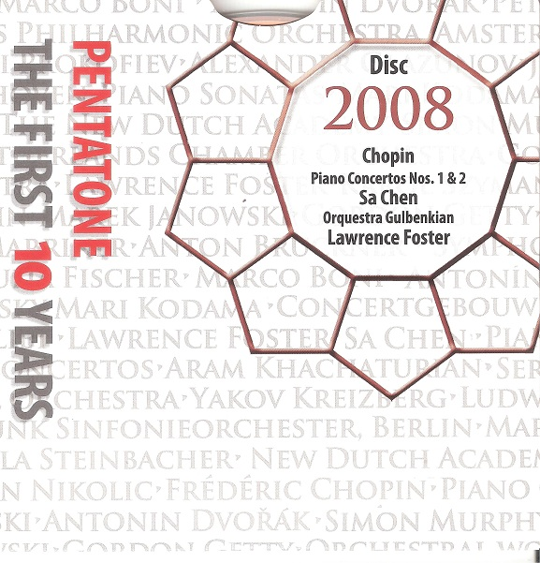

Формат записи/Источник записи: [SACD-R][OF]
Наличие водяных знаков: Нет
Год издания/переиздания диска: 2008
Издатель (лейбл): PentaTone
Жанр: Classical
Продолжительность: 01:14:25
Наличие сканов в содержимом раздачи: да
Треклист:
Frédéric Chopin (1810-1849)
PIano Concerto No.1 in E Major Op.11
1. Allegro Maestoso - 20:42
2. Romance - Larghetto - 9:57
3. Rondo - Vivace - 10:21
PIano Concerto No.2 in F Minor Op.21
4.Maestoso - 14:55
5.Larghetto - 9:36
6.Allegro Vivace - 8:56

Personnel:
Sa Chen - piano
Gulbenkian Orchestra
Lawrence Foster - conductor

Контейнер: ISO (*.iso)
Тип рипа: image
Разрядность: 64 (2,8 MHz/1 Bit)
Формат: DST64
Количество каналов: 2.0, 5.0
Original Recording Format: DSD64

(есть торрент 24/192 - https://rutracker.org/forum/viewtopic.php?t=3940254)
Источник (релизер): WEB.
SA-CD.net - PentaTone - The First 10 Years

Доп. информация:
Label: PentaTone Classics
SKU PTC 5186 341 [SACD]
Release Date: October 13, 2008
Original Recording Format: DSD64
Recording Type & Bit Rate: DSD64

Об альбоме (сборнике)
The Chongqing-born pianist Sa Chen first gained international recognition 12 years ago, delighting the audiences and judges of the Leeds Piano Competition with the delicate brilliance of her technique and her youth – at 16 years old, she was the youngest competitor that year. In the intervening years, having studied with Joan Havill at the Guildhall and won the 2005 Van Cliburn competition, she has recorded two discs, with JVC and Harmonia Mundi. The third and present disc contains the first fruits of her exclusive contract with the sharp-eared executives of PentaTone classics, recorded in Lisbon's Gulbenkian foundation last summer [July 2008] with the resident orchestra conducted by Lawrence Foster.
Possessed of exceptional talent and a grasp of Chopin's melancholic lyricism both instinctive and thoughtful, Sa Chen is a natural in this repertoire. Lovers of his two concertos will find themselves rewarded by an interpretation that emphasises the works' expanded intimacy, albeit at the expense of some of the drama. But all musicians succeed by playing to their strengths, and Chen's youthful, light-fingered self-confidence is certainly worth trusting, as swathes of Chopin's cascading gracenotes emerge limpid and gleaming, marked by a clarity of touch that clears the ear's path to every note. In both slow movements, played with generous but undisturbing rubato, Chopin's gently logical harmonies hang in the air just long enough to catch the falling arabesques, cushioning them gently before launching them off again to explore the wistful inner reaches of delight.
The orchestra follows her attentively and sensitively, never missing the pianist's cue. Only when stranded by themselves, at the mercy of Foster's somewhat leaden baton, does the poetry evaporate momentarily. But this is as much Chopin's fault as Foster's, particularly in the E minor concerto where the composer's ambition to give the orchestra a little more autonomy makes for some rather rough-edged architecture.
The recording quality is excellent, deep and well defined in stereo – presumably even better when played on the Super Audio equipment I do not possess. The bonus DVD contains some studio footage – offering visual confirmation of the orchestra's attentiveness to their diminutive guest – and an unremarkable interview with James Jolly in Bechstein's London showroom.

Reviews:
Linn-LP12 Mar 14, 2020
Beautiful. The only way to describe this.
Sa Chen plays Chopins piano concertos with superb emotion. Can't imagine why many do not have this on, at least, their want list. It's a Gem.

Review by hkpat March 31, 2010
2008 marked a special year in the annals of Chinese history. It was a year of firsts which included the first Olympics in Beijing and the first space walk by Chinese astronauts. If there was one event that could be nominated to represent China in 2008 in Classical Music it was Pentatone’s release featuring the Chinese pianist, Chen Sa. Since 2001, this UK record label has been known for its ultimate audio experience on hybrid multichannel SACDs. The present recording project with Sa Chen witnessed the company’s first ever collaboration with a Chinese musician as their soloist. This was also Ms. Chen’s début concerto recording.
A native from Chongqing, China, Sa Chen has since the early 1980s established herself as a world-class pianist. She caught the world’s attention when she won the Crystal Prize at the 12th Van Cliburn Piano Competition in 2005. Before this she had been a prize-winner at the Leeds Competition (1996) and the 4th International Chopin Competition (2000) in the latter of which she was awarded the “Best Polonaise Award”. The audience remarked on her interpretation of the Polonaise-Fantasy in A Flat as the work of a masterly expositor of Chopin’s lyrical spirit. Ever since, Ms. Chen has made a name for herself as a keynote interpreter of Chopin’s works. Listeners could easily pinpoint her signature qualities: delicacy of touch, polished rounded phrases, fluency of expression and introspective lyrical repose.
This release revisits a close relationship between Chen Sa and Chopin. Those who recall Ms. Chen‘s début disc “Chopin Impression” on JVC will find this Pentatone recording a welcome addition to her discography. It is replete with naturally expansive and elegant playing. Listeners will be delighted with her fluent dialogues with the orchestra in the first movement of the E Minor Concerto. Then there’s her splendidly phrased folk mazurka in the exuberant finale of the F Minor Concerto. How stunning also are the orchestral tremolandi in the Larghetto of the F Minor. Throughout the concertos, the music danced and ebbed as required. This recording easily rivals in excellence the recent release by the pianist’s compatriot Lang Lang.
What also sold the performances here was Chen Sa’s skilful ability to capture the youthful spirit and poise of the music as well as its growing maturity. Ms. Chen’s approach reflected the typically Chopin tensions of pianist vs. composer, overt virtuosity vs. restrained lyricism, and Classical vs. Romantic.
By: Patrick P.L. Lam

Review by John Broggio - October 22, 2008
A disc that is likely to prove controversial amongst listeners.
First, the unquestionably positive aspects of the disc; Lawrence Foster does his usual sterling work for orchestras in more straightforward works (for them!) and audibly inspires a highly polished and committed response from the Gulbenkian Orchestra Lisbon. The team work of Sa Chen and Foster is clearly evident too and the sense of togetherness is quite remarkable in a pair of concertos where the conductor all too often sounds like he is just beating time, with no care for the music - a charge which is completely without foundation here. Sa Chen's technique is quite astonishing - few if any pianists can have produced such a delicate, glittering and glowing tone throughout these works - a flood of gleaming white pearls kept coming to mind when listening - nor can many have audibly delineated the myriad of markings in the score. The tempo choices are steady, with no obvious revisionist tendencies on display.
What will not prove to be so universally admired though will be Sa Chen's way with rubato or choice of interpretation vis a vis the underlying drama of the concertos. Sa Chen adopts a light touch even at times of high dynamic markings, which makes for a wonderfully understated performance that firmly places the works as precursors to Saint-Seans piano concerto no.1 - some listeners may well miss the drama that is teeming beneath the surface. More problematic will be Sa Chen's tendency to elongate phrase endings almost endlessly - if this stylistic device was utilised sparingly, it would have been very touching but it is applied almost universally at the end of each long paragraph and so loses some of the emotional impact. On repetition, the spinning out of the line may well become wearing although when faced with such beauty it is perhaps churlish to grumble!
Pentatone's recording is unquestionably the finest sound that these works have ever been given and is astonishingly life-like; the balance between piano and orchestra is nigh-on perfect and the multi-channel recording gives a pleasing sense of being in an ideal stalls seat.

