Basso Cantante
Gary Karr
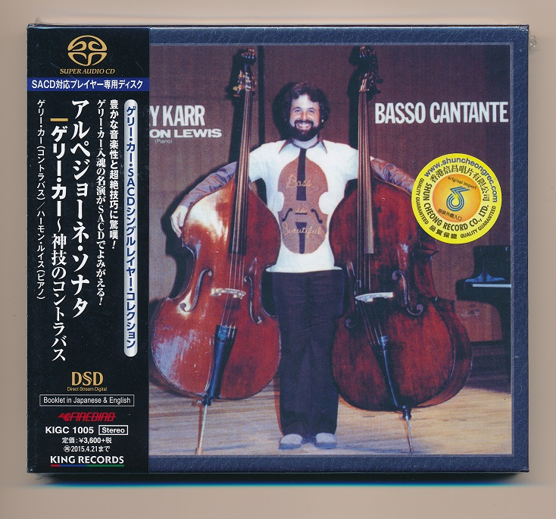

Формат записи/Источник записи: [SACD-R][OF]
Наличие водяных знаков: Нет
Год издания/переиздания диска: 1987
Издатель (лейбл): King International (Japan)
Жанр: Classical
Продолжительность: 00:45:14
Наличие сканов в содержимом раздачи: Только обложка альбома

Треклист:
Arpeggione Sonata
Composed by F. Schubert
1. 1st Mov.: Allegro - 9:50
2. 2nd Mov.: Adagio - 4:44
3. 3rd Mov.: Allegretto - 9:50

4. Vocalize - 4:06
Composed by S. Rachmaninoff

5. Le Cygne - 3:00
Composed by Saint Saens

6. The Entertainer - 1:24
Composed by S. Joplin

7. Kojo No Tsuki - 4:06
Composed by R. Taki

8. When I Wake Up in the Morning
Composed by – Folk - 3:08

Three Catalonian Carols
9. El Noi De La Mare - 2:04
10. Fum, Fum, Fum - 0:43
11. El Cant Dels Ocells - 2:19

Personnel:
Gary Karr - double bass “Amati, 1611”
Harmon Lewis - piano “Steinway & sons”
Контейнер: ISO (*.iso)
Тип рипа: image
Разрядность: 64 (2,8 MHz/1 Bit)
Формат: DST64
Количество каналов: 2.0
Original Recording Format: Abalog Tape
Источник (релизер): WEB.
Gary Karr Basso Cantate Single-Layer Stereo SACD (elusivedisc.com)

Доп. информация:
Label: King International
SKU KINSA1005
Release Date: Sep 21, 1987
Recording Location: King Records Studio, Tokyo, Japan
Recording Date: May 28-29, 1980
Original Recording Format: Analog Tape
Recording Type & Bit Rate: Analogue AAA Recording mastered to DSD64

Об альбоме (сборнике)
All Analogue AAA Recording, mastered by Kevin Gray from the Original Analogue Tapes! This release features Gary Karr performing with Harmon Lewis on piano for a group of classical pieces, folk songs, and carols by Schubert, Rachmaninoff, Saint-Saens, and more. Although it features Schubert's "Arpeggione Sonata", the gem on this recording is a Canadian folksong, "When I Wake Up in the Morning." It has been a staple encore piece of the Karr/Lewis Duo for 30 years since they lived in Nova Scotia. Gary Karr, acclaimed as "the world's leading solo bassist" (Time Magazine), is, in fact, the first solo double bassist in history to make that pursuit a full-time career. It is a career that adds new lustre to his already lustrous 1611 Amati double bass which was given to him by the widow of Serge Koussevitzky. Since his debut with Leonard Bernstein and the New York Philharmonic in 1962, Karr has performed as soloist on six continents with orchestras, including the Chicago Symphony, London Philharmonic Orchestra, Hong Kong Philharmonic, Montreal Symphony, Simon Bolivar Orchestra (Caracas, Venezuela), Jerusalem Symphony, Oslo Philharmonic, Zurich Chamber Orchestra, and with all the major orchestras of Australia.

