Gershwin, Ravel - Piano Concertos
Pascal Rogé, RSO Wien, Bertrand de Billy

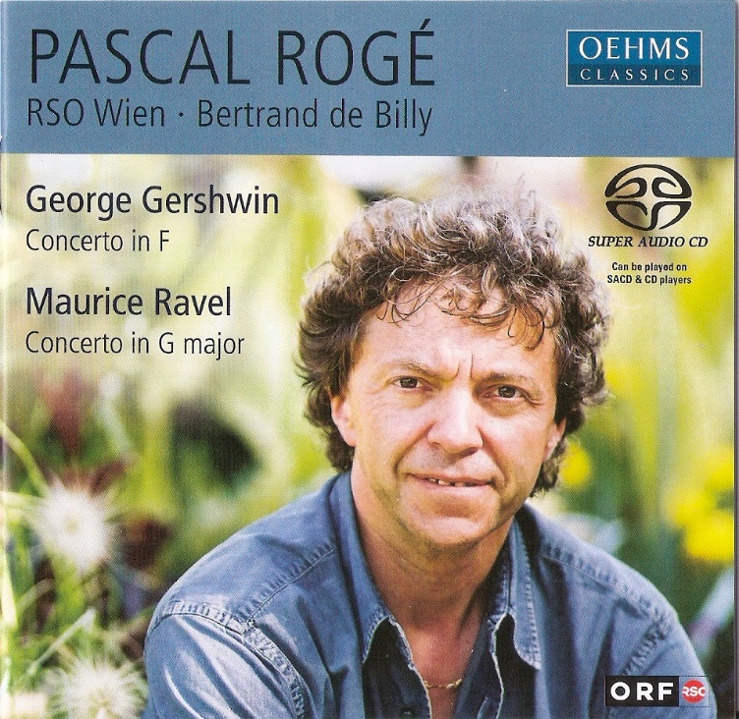

Формат записи/Источник записи: [SACD-R][OF]
Наличие водяных знаков: Нет
Год издания/переиздания диска: 2021
Издатель (лейбл): Oehms Classics
Жанр: Classical
Продолжительность: 01:51:31
Наличие сканов в содержимом раздачи: да

Треклист:
George Gershwin - Concerto in F for Piano and Orchestra
1. Concerto in F, for piano & orchestra: Allegro - 13:50
2. Concerto in F, for piano & orchestra: Adagio. Andante con moto - 12:11
3. Concerto in F, for piano & orchestra: Allegro agitato - 06:57

Maurice Ravel - Concerto for Piano and Orchestra in G-Major
4. Piano Concerto in G major: Allegramente - 08:49
5. Piano Concerto in G major: Adagio assai - 09:45
6. Piano Concerto in G major: Presto - 04:04

Personnel:
Pascal Rogé (piano)
RSO Wien
Bertrand de Billy (conductor)
Контейнер: ISO (*.iso)
Тип рипа: image
Разрядность: 64 (2,8 MHz/1 Bit)
Формат: DST64
Количество каналов: 2.0, 5.1
Original Recording Format: PCM
Источник (релизер): WEB.
SA-CD.net - Gershwin, Ravel: Piano Concertos - Pascal Rogé

Доп. информация:
Label: Oehms Classics OC 601
Release Date: May 14, 2021
Recording location: ORF Wien, Radiokulturhaus, February, 2004

Original Recording Format: PCM
Recording Type & Bit Rate: DSD64

Об альбоме (сборнике)
Here’s a disc whose breathtaking sonic detail and attractive, roomy ambience make a cogent case for investing in SACD surround-sound hardware, although it sounds perfectly fine and vivid enough via standard stereo two-channel playback. Regarding the performance, pianist Pascal Rogé here surpasses his early-1980s Ravel Concerto recording under Charles Dutoit. He makes more of the first movement’s lyrical, unaccompanied episodes, yet never overindulges, and he treats the central slow movement like a song rather than a dirge, with tasteful droplets of rubato. The finale’s busy fingerwork appears to fly off the printed page through Rogé’s incisive articulation and biting accents. Just listen to his dazzling repeated notes here and in the finale of Gershwin’s concerto. The latter also finds Rogé in dapper fettle and fully attuned to the composer’s syncopated swagger.
Bertrand de Billy elicits alert and translucent playing from the Vienna Radio Symphony Orchestra, aside from thin, undifferentiated string tone and some less than idiomatic first-desk solo work in the Gershwin. While these performances won’t make you forget the above-mentioned reference versions, nor recent contenders of equal stature (like Grimaud’s Gershwin and Moravec’s Ravel), their combined sonic and interpretive assets add up to a pleasurable and memorable listening experience.
Jed Distler - www.classicstoday.com

Reviews:
Site review by akiralx January 6, 2005
Performance: 4,5 Sonics: 5
Yep, I agree with the previous review - this is a very fine release, especially the Gershwin. What is remarkable is how idiomatically the Vienna Radio SO play in this, with a beautifully sleazy trumpet glissando near the beginning of the slow movement - in music with which they can hardly be familiar.
Roge's performance is slightly more relaxed than another favourite of mine, Andre Previn on EMI - but none the worse for that, and de Billy's orchestra more than match Previn's own LSO. Occasionally Roge leans on an accent a little heavily compared to the fleet-fingered Previn - but he more than compensates by his jazzy rubato and rhythmic subtlety.
The Ravel is also enjoyable if not quite at the same high level - this is very competitive repertoire with superb versions by Michelangeli, Zimerman, Collard, Francois and a host of others, but I think he has the field to himself in terms of multichannel SACD.
Soundwise this is very good - the piano sound is excellent and superbly integrated into the orchestral fabric, who themselves make wonderful sounds especially in the Gershwin central slow movement. In multichannel this sounds very natural and enjoyable.
I listened to the stereo layer through my Stax Classic earspeaker system, and the results were outstanding - beautiful orchestral textures and perfect piano sound, wonderfully integrated.
Strongly recommended for the outstanding Gershwin - and the Ravel is a more than fine bonus.

Review by jdaniel@jps.net October 30, 2004
Performance: 4,5 Sonics: 5
A winning disc. Who would have thought: Ravel and Gershwin Piano concerti on SACD so soon--and with Pascal Roge no less! Roge tosses off an exciting and fragrant performance of the Ravel. Listen to the tocatta-like material in the first mov't--if this doesn't raise the hairs, I don't know what will. The slow mov't is a still, crystaline beauty; the contributions of the RSO Wien winds are lovely. The finale zips along--listen to the shading of the final piano tremolo--loving touches like this abound throughout the performance. Never did the collective and individual abilities of the orchestra sound wanting to my ears in this difficult music. If anyone doubts the magic of discreet surround, have them listen to the opening of the slow moves of the Gershwin. Never have I heard this music sound so atmospheric--humid, in fact. The RSO Wein under de Billy are alive and alert--lush when they need to be, and (95%) idiomatically jazzy. Gershwin is in good hands here with Roge, and the orchestra accompaniment is excellent in mov'ts two and three. (Listen to that gong that heralds the re-entry of the motto theme for the finale of the 3rd mov't. Wow!) If you know your Gershwin through MTT or Bernstein, you might find portions of the prickly 1st mov't to be just a touch heavy-handed. Just a touch. The recording in surround is wide and deep--lush, similar to the house sound of Pentatone. Excellent release.

