Gordon Getty Orchestral Works
PentaTone - The First 10 Years (2003-2011)
Academy of St. Martin in the Fields, Sir Neville Marriner

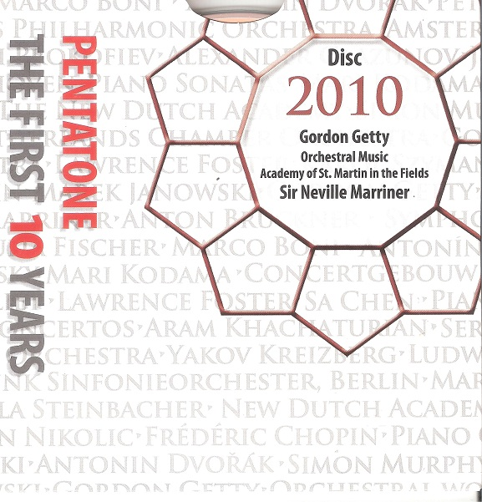

Формат записи/Источник записи: [SACD-R][OF]
Наличие водяных знаков: Нет
Год издания/переиздания диска: 2010
Издатель (лейбл): PentaTone
Жанр: Classical
Продолжительность: 01:00:13
Наличие сканов в содержимом раздачи: да
Треклист:
1. Overture "Plump Jack" - 12:12
2. Ancestor Suite - Zwei Walzer - 02:51
3. Ancestor Suite - Waltz of the Ancestors - 01:49
4. Ancestor Suite - Schottische - 01:19
5. Ancestor Suite - Waltz - Landler - 03:52
6. Ancestor Suite - Polka - Polonaise - 02:54
7. Ancestor Suite - Gavotte - 01:43
8. Ancestor Suite - Gothic Waltz - 02:36
9. Ancestor Suite - March - Sarabande – Presto - 04:53
10. Ancestor Suite - Madeline - 03:30
11. Ancestor Suite - Ewig Du - 04:40
12. Ancestor Suite - Finale - 01:59
13. Tiefer und Tiefer - 04:12
14. Homework Suite - Seascape - 01:11
15. Homework Suite - Giga - 00:42
16.Homework Suite - Ghost Waltz - 00:55
17. Homework Suite - Berceuse - 02:14
18. Homework Suite - Night Horses - 01:07
19. The Fiddler of Ballykeel - 03:02
20. Raise the Colors - 02:34

Personnel:
Academy of St. Martin in the Fields
Sir Neville Marriner (conductor)

Контейнер: ISO (*.iso)
Тип рипа: image
Разрядность: 64 (2,8 MHz/1 Bit)
Формат: DSD
Количество каналов: 2.0, 5.0
Original Recording Format: DSD64
Источник (релизер): WEB.
SA-CD.net - PentaTone - The First 10 Years

Доп. информация:
Label: Pentatone
SKU PTC 5186 500 (11 discs)
Release Date: March 30, 2010
Recording Date: April, 2009
Recording Location: Air Lyndhurst Studios, Hampstead, England
Original Recording Format: DSD64
Recording Type & Bit Rate: DSD64

Об альбоме (сборнике)
The San Francisco-based Gordon Getty is most widely known to music lovers through his vocal works, perhaps not surprising for a composer who in his student years studied not only composition and piano but also voice. Most of his compositions have involved the voice, and his three previous recordings on PentaTone Classics have all featured vocal works: his widely performed song cycle The White Election, to poems by Emily Dickinson; his cantata Joan and the Bells, on the Joan of Arc story; and Young America, a collection of his choral compositions. (The White Election, in fact, has been issued in two separate commercial recordings.) But to most music-lovers, the work of Getty’s that most readily springs to mind is Plump Jack, a two-act opera that was premiered in a concert production by the San Francisco Symphony in 1987 (that orchestra had presented an excerpt from the work-in-progress four years earlier) and since then has been performed in whole or part by such organizations as the Los Angeles Chamber Orchestra, BBC Philharmonic, Festival of the Two Worlds (Spoleto, Italy), Aspen Music Festival, London Philharmonia with London Voices, Puerto Rico Symphony, New Mexico Symphony, and Orquesta Sinfónica Sinaloa de las Artes (Mazatlán, Mexico).

Review:
Gordon Getty: Orchestral Works Review by James Manheim
Gordon Getty, by some reckonings the world's richest individual, is also a classical composer. He has generously supported opera and also composed the Falstaff-themed Plump Jack, whose overture is included here. Most of the music for which he has gained wide attention is vocal, but here is a selection of instrumental pieces, recorded in London, for a boutique Dutch audiophile label no less, with the 86-year-old Neville Marriner returning to the podium before the Academy of St. Martin-in-the-Fields to do the honors. The London location is actually the least surprising, for Getty's style is more British than American. Getty has said that he is "two-thirds a 19th-century composer," and the Stravinsky-like dances in the Ancestor Suite, extracted from ballet music that you may not recognize as being inspired by the writings of Poe, doesn't do much to jazz up the conservative atmosphere. Yet the music doesn't exactly fit the neo-Romantic category; it's economical and brisk, for one thing, and it's full of little flashes of novelty -- listen to the end of the Overture to Plump Jack, for example -- that don't come from any other specific place. The short pieces on the second half of the program are pretty light stuff, but taken for what it is, Getty's music is competently done. Transparent sonics and a performance by the ensemble perhaps best suited to the music are both helpful, and you might put this disc on a top-notch stereo and quiz your friends as to the composer. Booklet notes are in English, German, and French.

