Handel - Recorder Sonatas
Pamela Thorby, Richard Egarr
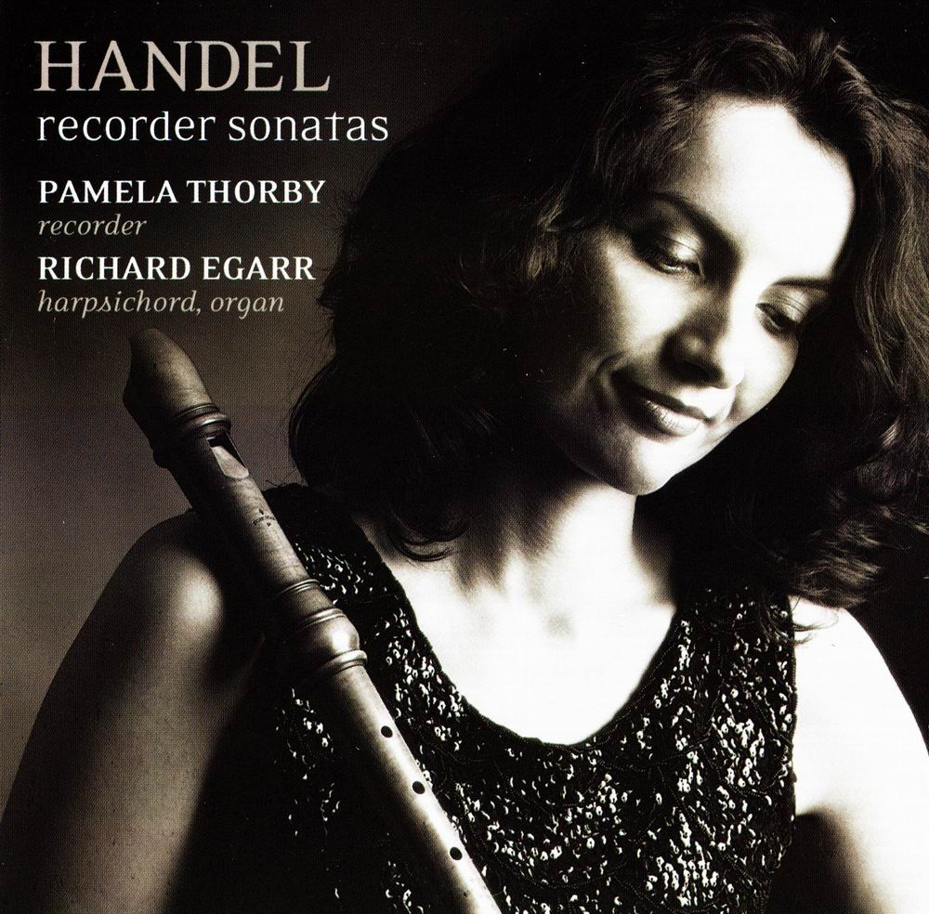

Формат записи/Источник записи: [SACD-R][OF]
Наличие водяных знаков: Нет
Год издания/переиздания диска: 2004
Издатель (лейбл): Linn Records
Жанр: Classical
Продолжительность: 01:14:18
Наличие сканов в содержимом раздачи: Только обложка альбома

Треклист:
01. Sonata in D minor HWV 367a – Largo - 02:14
02. Vivace - 03:08
03. Furioso - 02:00
04. Adagio - 01:20
05. Alla breve - 01:47
06. Untitled - 02:44
07. A tempo di menuet - 01:38

08. Sonata in B flat major HWV 377 – Untitled - 02:12
09. Adagio - 01:19
10. Allegro - 02:39

11. Sonata in C major HWV 365 – Larghetto - 02:44
12. Allegro - 02:16
13. Largetto - 02:01
14. A tempo di gavotte - 02:14
15. Allegro - 02:27

16. Harpsichord suite in E major HWV 430 – Prelude - 02:04
17. Allemande - 05:33
18. Courante - 01:55
19. Air with doubles - 04:34

20. Sonata in major HWV 369 – Grave - 02:28
21. Allegro - 02:23
22. Alla Siciliana - 01:14
23. Allegro - 02:01

24. Sonata in A minor HWV 363 -Llarghetto - 02:34
25. Allegro - 02:27
26. Adagio - 02:07
27. Allegro - 03:30

28. Sonata in G minor HWV 360 – Larghetto - 02:18
29. Andante - 03:26
30. Adagio - 00:46
31. Presto - 02:01

Personnel:
Pamela Thorby - recorder
Richard Egarr - harpsichord, organ
Контейнер: ISO (*.iso)
Тип рипа: image
Разрядность: 64 (2,8 MHz/1 Bit)
Формат: DST64
Количество каналов: 2.0, 5.1
Original Recording Format: PCM
Источник (релизер): WEB.
Handel - Pamela Thorby & Richard Egarr – Recorder Sonatas (2004, DSD / HDCD, SACD) - Discogs

Доп. информация:
Label: Linn Records CKD 223
Release Date: August, 2004
Recorded at The National Centre for Early Music, York - 3rd & 4th June 2003
Original Recording Format: PCM
Recording Type & Bit Rate: DSD64

Об альбоме (сборнике)
Pamela Thorby has an international reputation as one of the most versatile and stylish recorder players of her generation. Her virtuoso playing can be heard on numerous CD's, ranging from the medieval period to the present day. Pamela is perhaps best known for her baroque playing with the Palladian Ensemble (with whom she has recorded nine acclaimed albums), but also as a soloist with the English Concert and many other eminent UK orchestras. Her Baroque Concertos CD for LINN Records received outstanding reviews in 2003.
Pamela and Richard began their musical partnership as students together at the Guildhall School of Music and Drama, leading to acclaimed duo recitals at the Purcell Room and the Wigmore Hall in London. They have appeared in concert and on disc together on many occasions as their respective careers progressed, but this is the first time that they have recorded together as a duo.

