Heartbreak - Romantic Encores for Violin
Elissa Lee Koljonen, Robert Koenig
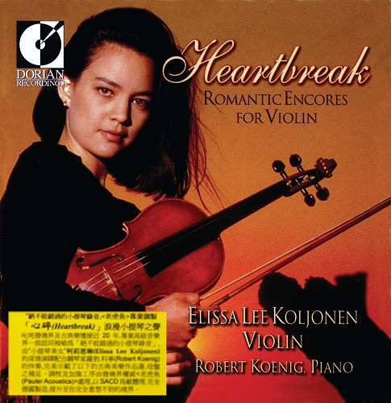

Формат записи/Источник записи: [SACD-R][OF]
Наличие водяных знаков: Нет
Год издания/переиздания диска: 2015
Издатель (лейбл): Dorian Recordings
Жанр: Classical
Продолжительность: 01:12:34
Наличие сканов в содержимом раздачи: Только обложка альбома

Треклист:
1. Nocturne in C-sharp Minor, Op. posth. - Frédéric Chopin (1810-1849) / Milstein - 4:16
2. Salut d'amour, Op. 12 - Edward Elgar (1857-1934) - 2:49
3. Vocalise, Op. 34, No. 14 - Sergei Rachmaninoff (1873-1943) / Press - 5:43
4. Liebeslied (Love's Sorrow) - Fritz Kreisler (1875-1962) - 3:34
5. The Old Refrain (Viennese Popular Song) – Kreisler - 3:28
6. Consolation No. 3 in D-flat Major: Lento placido - Franz List (1811-1886) / Milstein - 3:56
7. Sea-Shell - Carl Engel (1883-1944) / Zimbalist - 3:37
8. Meditation from Thais - Jules Massenet (1842-1912) - 5:21
9. Valse sentimentale, Op. 51, No. 6 - Peter Ilyich Tchaikovsky (1840-1893) / Press - 3:00
10. Nocturne, Op. 27, No. 2 – Chopin / Wilhelmj - 6:15
11. Pavane pour une infante defunte - Maurice Ravel (1875-1937) / Kochanski - 5:49
12. Beau soir - Claude Debussy (1862-1918) / Heifetz - 2:27
13. Romanza (Albumblatt) - Richard Wagner (1813-1883) / Wilhelmj - 4:27
14. "O mio babbino caro" from Gianni Schicchi - Giacomo Puccini (1858-1924) - 2:28
15. "Love" (Korean Traditional Song) - Hong Nan Pa - 2:04
16. Zigeunerweisen (Gypsy Airs), Op. 20, No.1 - Pablo de Sarasate (1844-1908) - 9:22
17. Contemplation - Johannes Brahms (1833-1897) / Heifetz - 2:43

Personnel:
Elissa Lee Koljonen - violin (made by the Italian Lorenzo Storioni in 1787)
Robert Koenig - piano
Контейнер: ISO (*.iso)
Тип рипа: image
Разрядность: 64 (2,8 MHz/1 Bit)
Формат: DST64
Количество каналов: 2.0
Original Recording Format: PCM
Источник (релизер): WEB.
Elissa Lee Koljonen – Heartbreak - Romantic Encores for Violin (2015, SACD) - Discogs

Доп. информация:
Label: Dorian Recordings - DOR-90268
Release Date: 2015
Recording location: Sept. 1998, Troy Savings Bank Music Hall, NY.
Original Recording Format: PCM
Recording Type & Bit Rate: DSD64

Об альбоме (сборнике)
"Heartbreak" Romantic Encores for Violin - Nearly 20 years in the audiophile and classical music scene, it has been regarded as one of the must-haves listening albums for testing high-end audio, and has been selected as one of the editors-in-chief of the Audio Forum "Liu Hansheng CD List", which is unanimously recognized by the professional senior music community. In 1999, the American classical brand < Dorian > the female violinist Eliza Lee, who was awarded the order of the United States at that time, had high musical knowledge, extraordinary talent, and was known as the "violin beauty". plum. The debut solo album by Elissa Lee Koljonen. She worked in "Karl. The Baltimore Sun was praised for "winning a silver medal at the Carl Flesch International" and winning a violin performance award at the Henryk Szeryng Foundation, and the Baltimore Sun was praised for "She is the most talented violinist I've ever heard in recent years, and her future achievements are limitless..." In the sound of the romantic violin "Heartbreak", Coleen played a valuable violin made by the Italian Lorenzo Storioni in 1787, with the pianist Robert Bergeron. The accompaniment of Robert Koenig perfectly demonstrates the selection of classical music works.

