Hieronymus Praetorius - Organ Works
Organ Works of the North German Baroque - Vol. 9
Friedhelm Flamme - organ
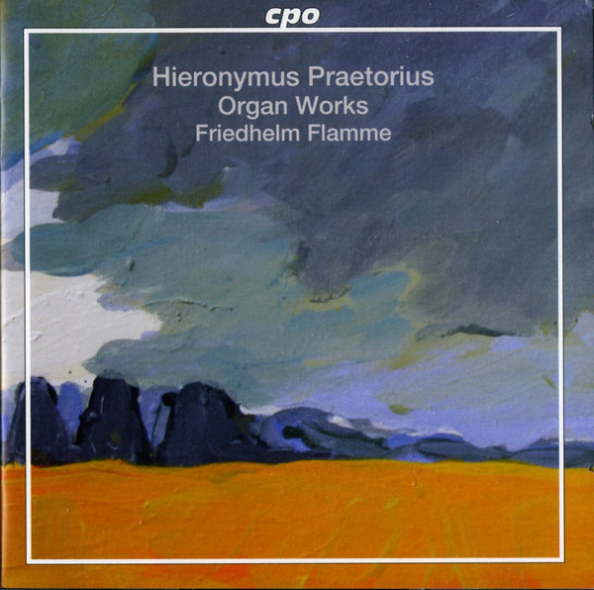

Формат записи/Источник записи: [SACD-R][OF]
Наличие водяных знаков: Нет
Год издания/переиздания диска: 2012
Издатель (лейбл): CPO (Classic Produktion Osnabrück)
Жанр: Classical/ Organ
Продолжительность: 02:15:35
Наличие сканов в содержимом раздачи: Только обложка альбома

Треклист:
Hieronymus Praetorius (1560-1629)
1-1. Magnificat Primi Toni - 7:03
1-2. Magnificat Secundi Toni - 6:27
1-3. Wenn Mein Stündlein Vorhanden Ist - 7:02
1-4. Magnificat Tertii Toni - 10:23
1-5. Magnificat Quarti Toni - 9:00
1-6. Lucis Creator Optime - 4:51
1-7. Veni Creator Spiritus - 6:28
1-8. Veni Redemptor Gentium - 5:09
1-9. Christ, Unser Herr, Zum Jordan Kam - 8:20
2-1. Magnificat Quinti Toni - 10:16
2-2. Magnificat Sexti Toni - 8:14
2-3. Kyrie Summum - 6:10
2-4. Gloria in Excelsis Deo / Et in Terra Summum - 5:11
2-5. Sanctus Summum - 2:24
2-6. Agnus Dei - 3:44
2-7. Sequentia: Sancti Spiritus Adsit Nobis Gratia - 3:02
2-8. In Exitu Israel De Aegypto (Psalm 133) - 2:40
2-9. Magnificat Germanic - 3:25
2-10. Magnificat Septimi Toni - 14:15
2-11. Magnificat Octavi Toni - 11:29

Personnel:
Friedhelm Flamme - Organ [Scherer-Orgel]
Контейнер: ISO (*.iso)
Тип рипа: image
Разрядность: 64 (2,8 MHz/1 Bit)
Формат: DST64
Количество каналов: 2.0, 5.1
Original Recording Format: PCM
Источник (релизер): WEB.
Hieronymus Praetorius - Friedhelm Flamme – Organ Works (2012, SACD) - Discogs

Доп. информация:
Label: CPO (Classic Produktion Osnabrück) cpo – 777 345-2
Release Date: Jun 26, 2012
Recording: St. Stephanskirche, Tangermünde, Germany, August 1-4, 2007
Original Recording Format: PCM
Recording Type & Bit Rate: DSD64

Об альбоме (сборнике)
Hieronymus Praetorius (1560–1629) is not to be confused with his far more famous but unrelated contemporary Michael Praetorius (the surname being a Latinization of the original German one, “Schulze”). Relatively little is known of his life. Born in Hamburg, he was the son of an organist named Jacob Praetorius (not to be confused with Hieronymus’s son of the same name, who was also an organist and composer). He was trained on that instrument, first by his father and then by Hinrich thor Molen in Hamburg in 1573, and then studied in Cologne under Albinus Walran (or Walraff); dates for the latter period are variously given as 1574–76 and 1577–78. After serving briefly as an organist in Erfurt from 1580 to 1582, he returned to his native Hamburg to assist his father, succeeding him as organist of the Lutheran Jacobikirche (Church of St. James) in 1586 and holding that post to the end of his life. A marriage produced seven children; three of his four sons also became organists. He appears to have traveled little, but he did meet Michael Praetorius and Hans Leo Hassler at an organ examination in Gröningen in 1596.
Most of the compositions of Hieronymus were published in a series of five volumes between 1616 and 1625; they include 102 motets and six parody Masses. (He also was the chief compiler of a collection of 88 four-part German chorale settings, the 1604 Melodeyen Gesangbuch, notable for being the first collection of German hymns to specify organ accompaniment to congregational singing.) Along with Michael Praetorius, Hassler, and Jacobus Gallus, Hieronymus was one of the key pioneers of the new Venetian polychoral style of composition in Germany. The eight organ settings of the Magnificat, one each in the canonical eight tones, that comprise most of the contents of this disc survive in the Visby Tablature, a manuscript assembled in 1611 by Berendt Petri (a pupil of the first Jacob Praetorius; his dates of birth and death are unknown) and preserved in the city of Visby on the Swedish island of Gotland; most of the 41 anonymous short pieces in that manuscript are now ascribed to Hieronymus as well. Of those, several have been selected for inclusion on this disc, as well as two chorale fantasias and one other Magnificat setting (preserved in the Clausthal-Zellerfeld Tablature, also dating from the early 1600s) also definitely known to be by Hieronymus. All of the eight Visby Magnificat settings follow the same basic pattern of setting “verses” or discrete compositional units, first in the tenor part, then the descant, and then the bass; three interject or append one or two additional verses with the indication “Vp 2 Clauier” (on two manuals), while one other setting adds a fugue. Each of these verses elaborates on the cantus firmus line in various ways, sometimes with strict counterpoint and at other times more freely.
Despite the employment of the new Venetian style, these pieces are also definitely anchored in older Renaissance dance forms, and are not as imaginative as those of Jan Sweelinck, featured on a recent MDG release that I reviewed in 35:3. However, they are important examples of early organ music in early 17th-century Germany, and this appears to be the first recording they have received. The performances (on the 1624 Scherer organ of St. Stephen’s Church in Tangermünde) are well done, and the SACD recorded sound brings out all facets of the organ clearly, though again it is not as impressive as on the aforementioned MDG disc of Sweelinck’s music. Most helpfully, each verse within each of the Magnificats has its own track, and the booklet notes provide both detailed specifications of the organ’s construction and precise indications of the registrations used in playing each verse. Duly recommended to all devotees of organ music before Buxtehude and Bach.

Hieronymus Praetorius - Profile:
German composer and organist of the late Renaissance and very early Baroque eras (born 10 August 1560 in Hamburg - died 27 January 1629 in Hamburg).
He was the son of Jacob Praetorius the Elder and succeeded him as organist of St. Jacobi, Hamburg from 1586 to his death, but is unrelated to Michael Praetorius, though he met him in the Gröningen organ examination of 1596, alongside Hans Leo Haßler. His son Jacob Praetorius was also a composer and organist.

Reviews:
This new release in the series featuring organ literature of the Northern German Baroque has Flamme interpreting works by Praetorius performed on the organ in St. Stephen's Church in Tangermünde, Germany. This is the only instrument by important organ builder Scherer that continues to display its magnificently carved case and about fifty percent of its original pipes, including all the front pipes. It proves to be the ideal instrument for the authentic performance of organ music from this period.

Reviewed in the United States on October 12, 2012
This is an absolutely stunning recording. Over two discs, Friedhelm Flamme brings us the superb cycle of organ Magnificat settings on the eight church modes, composed by one of the first great masters of baroque keyboard music, Hieronymus Praetorius (1560-1629). This eminent composer was no relation to Michael Praetorius of Wolfenbüttel, but belonged to the distinguished family of Hamburg musicians which also included a Johann and a couple of Jakobs, who have also popped up in recordings from time to time.
In many ways the scope and profundity of this cycle - as well as its thematic material - remind me of Nicolas Gombert's masterly collection of vocal Magnificat settings on the eight tones, composed around 50 or 60 years earlier. Be that as it may, the music is enthralling, majestic and strongly contrasted between the various settings in mood and colour. Try, for example, the sonorous opening Magnificat primi toni (disc I, track 1) and compare it to the more subdued second-tone setting (I/2). The eight Magnificats are interspersed over these two CDs with some of the composer's organ settings of Latin hymns, Mass movements and a couple of Lutheran chorales. My own favourites include Veni creator spiritus (I/7), Sanctus (II/5), Sequentia Sancti spiritus (II/7) and the Magnificats in the 5th and 8th tones which start and end the second disc.
Friedhelm Flamme has the full measure of all this music, giving a totally committed, profoundly expressive and perfectly paced performance throughout. His mastery of the rapid passagework and decorations required by Praetorius is dazzling, just as is the music itself. And what is more, Flamme is at the keyboard of one of the finest historic organs in the universe, the 1624 Scherer instrument of the Stephanskirche, Tangermünde, superbly restored in the early 1990s by Alexander Schuke Orgelbau of Potsdam. The player simply revels in the beauty, splendour and variety of its registrations, and so does the listener.
I would love to see this organ series from CPO find a different source for its cover pictures, though. These wishy-washy paintings of flat north German landscapes evidently appeal to somebody, but I find them as dull as dishwater; surely, they could use an appropriate painting or engraving from the period, or even a photo of the organ or player - anything rather than this. But we must not be put off by such trivia, for altogether this is a fabulous organ recording. I have already greatly enjoyed Flamme's other discs in this series, including music by Johann Praetorius and Georg Böhm, but for me this present one is probably his finest yet, and it's an absolute feast for baroque organ enthusiasts.

