Joseph Schmitt - Early Symphonies and Chamber Music
PentaTone-The First 10 Years (2003-2011)
New Dutch Academy, Simon Murphy

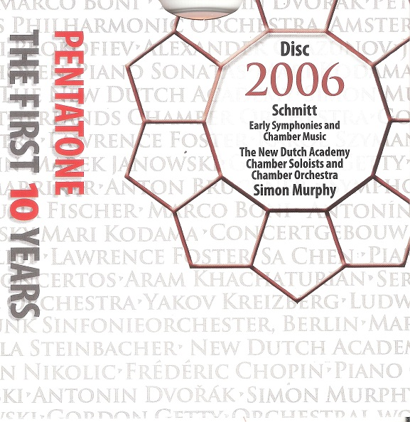

Формат записи/Источник записи: [SACD-R][OF]
Наличие водяных знаков: Нет
Год издания/переиздания диска: 2006
Издатель (лейбл): PentaTone
Жанр: Classical
Продолжительность: 01:18:05
Наличие сканов в содержимом раздачи: да
Треклист:
Joseph Schmitt (1734-1791)
1. Symphony in D major - Allegro molto - 03:39
2. Symphony in D major - Andante - 04:05
3. Symphony in D major - Menuetto - 03:41
4. Symphony in D major - Presto - 03:06
5. Symphony in B flat major - Allegro Maestoso - 04:51
6. Symphony in B flat major - Andante - 02:24
7. Symphony in B flat major - Allegro - 01:53
8. Symphony in G major - Allegro con Brio - 03:35
9. Symphony in G major - Largo - 04:04
10. Symphony in G major - Allegro - 02:51
11. Quartet for Flute, Violin, Viola and Cello in E minor - Moderato - 08:06
12. Quartet for Flute, Violin, Viola and Cello in E minor - Grazioso - 01:52
13. Quartet for Flute, Violin, Viola and Cello in E minor - Allegro Fugato - 07:03
14. Quartet for Flute, Violin, Viola and Cello in G major - Moderato - 07:17
15. Quartet for Flute, Violin, Viola and Cello in G major - Adagio - 03:01
16. Quartet for Flute, Violin, Viola and Cello in G major - Tempo di Gavotta - 02:22
17. Symphony in E flat major ‘The Hurdy Gurdy’ - Allegro con spirito - 04:11
18. Symphony in E flat major ‘The Hurdy Gurdy’ - Andante - 06:00
19. Symphony in E flat major ‘The Hurdy Gurdy’ - Prestissimo - 04:04

Personnel:
New Dutch Academy
Simon Murphy - conductor

Контейнер: ISO (*.iso)
Тип рипа: image
Разрядность: 64 (2,8 MHz/1 Bit)
Формат: DST64
Количество каналов: 2.0, 5.0
Original Recording Format: DSD64
Источник (релизер): WEB.
SA-CD.net - PentaTone - The First 10 Years

Доп. информация:
Label: Pentatone
SKU PTC5186039
Release Date: June 27, 2006
Recording Date: March 8, 2004 - March 10, 2004
Recording Location: Oud-Katholieke Kerk, The Hague, The Netherlands
Original Recording Format: DSD64
Recording Type & Bit Rate: DSD64

Об альбоме (сборнике)
This world premiere recording documents one of the most exciting discoveries in classical music in recent times. Displaying Schmitt working in both the symphonic and chamber mediums, this disc presents a musical portrait of this multifaceted 18th century German Dutch master composer. In bringing alive his music, the disc aims to profile Schmitt’s rich, cosmopolitan musical language and to illustrate how he creates his own personal language out of the myriad of international musical influences, musical styles and musical dialects presented to him by the creative whirlwind that was the 18th century European enlightenment.
Note about the Symphony in E-Flat Major, "The Hurdy-Gurdy”: In the 18th century, the term "Hurdy-Gurdy" was also applied to a small portable organ known in France as "Barbary organ" (Orgue de Barbarie), in English as "Barrel organ", and in Germany as "Drehorgel".

New Dutch Academy
Founded by conductor and violist Simon Murphy, The New Dutch Academy (NDA) is an award-winning group of 40 international young, highly engaged musicians who explore and perform 18th century music in all its forms.
Performing exclusively on authentic instruments, and appearing in its two forms – Chamber Soloists (4 to 12 musicians) and Chamber Orchestra (25 to 40 musicians) – the NDA has quickly won international acclaim for its fresh, vibrant and dynamic performance style, ever since its establishment in 2002.
The NDA’s innovative programming of classic as well as newly rediscovered 18th century masterworks offers modern audiences’ new insights into the music of composers such as Bach, Mozart, Beethoven and their contemporaries.
The NDA has won praise for shedding new light on the richness of the 18th century music culture, for example with its work investigating and profiling the Mannheim and Dutch 18th century symphonic schools.

