Sigfrid Karg-Elert - Ultimate Organ Works Vol. 4
Elke Völker - organ
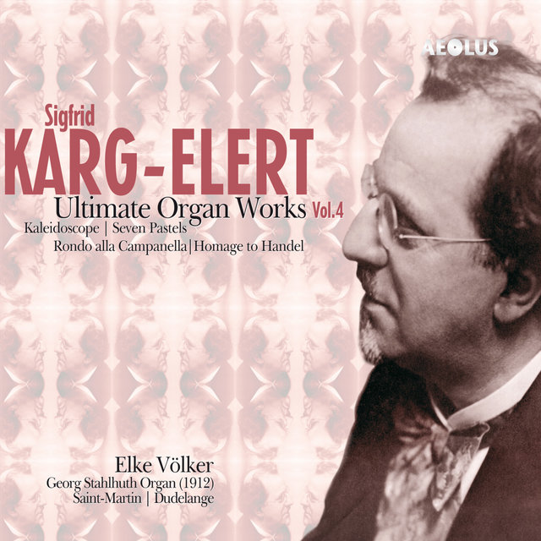

Формат записи/Источник записи: [SACD-R][OF]
Наличие водяных знаков: Нет
Год издания/переиздания диска: 2008
Издатель (лейбл): Aeolus
Жанр: Classical
Продолжительность: 01:09:35
Наличие сканов в содержимом раздачи: Только обложка альбома

Треклист:
Sigfrid Karg-Elert (1877-1933)
1. Kaleidoscope, for organ, Op. 144 - 19:31
Pastels (7) from the Lake of Constance, for organ, Op.96
2. The Soul of the Lake - 05:13
3. Landscape in Mist - 04:07
4. The Legend of the Mountain - 04:07
5. The Reed-Grown Waters - 03:09
6. The Sun's Evensong - 04:31
7. The Mirrored Moon - 05:13
8. Hymn to the Stars - 04:46
9. Rondo alla campanella, for organ, Op. 156 - 04:36
10. Homage to Handel, 54 studies for organ in variation form on a bass of Handel - 14:22

Personnel:
Elke Völker - Georg Stahlhuth organ (1912)
Контейнер: ISO (*.iso)
Тип рипа: image
Разрядность: 64 (2,8 MHz/1 Bit)
Формат: DSD
Количество каналов: 2.0, 5.0
Original Recording Format: PCM
Источник (релизер): WEB.
SA-CD.net - Karg-Elert: Ultimate Organ Works Vol. 4 - Elke Völker
AE10511 Karg-Elert, Sigfrid Karg-Elert - Ultimate Organ Works Vol.4 / All Discs / AEOLUS - aeolus-music.com

Доп. информация:
Label: Aeolus
AE-10511
Release Date: May 1, 2008
Recording location: Saint-Martin, Dudelange, Luxemburg
Original Recording Format: PCM
Recording Type & Bit Rate: DSD64

Об альбоме (сборнике)
Volume 4 of our Sigfrid Karg-Elert Edition contains an impressive collection of large-scale secular organ works: Kaleidoscope, Seven Pastels from the Lake Constance, Rondo and Homage to Handel.
As already on volume 3 (AE-10431) of this editon, the Georg Stahlhuth organ (1912) of Saint-Martin in Dudelange, restored by Thomas Jann in 2002, again is an ideal instrument for Karg-Elert's music - and Elke Völker is absolutely in her element here. She found incredibly beautiful registrations (based on Karg-Elerts indications of course!), especially in the Seven Pastels from the Lake Constance.
Kaleidoscope op.144 is a rather unknwon composition and can be considered as a brother of the big Symphonie in f sharp (op.143, recorded on Vol.1, AE-10121), because of some similarities in structure and harmonic language. The Seven Pastels are really close to the technical limits of the organ. The cycle is Karg-Elert's only large-scale impressionistic composition and takes the expressive potential of the organ to its outer limits.
Rondo alla campanella is a dazzling 169-bar Allegrissimo in 3/8 time, in semiquavers throughout like a french Toccata.
Homage to Handel is a series of 54 variations on a ground bass of Handel. It's a guide through all kinds of registrations of the wonderful Stahlhuth organ.
This is the first time we recorded this instrument in surround sound and as far as we know the first available Super Audio CD of this organ!

About AEOLUS
AEOLUS is a record label specializing in Baroque Music and music for organ. Our goal, and that of our artists, is to present superb interpretations performed on the most appropriate instruments. In order to achieve this, we often travel throughout Europe to record rare historical instruments.
We also strive to attain the best results in terms of sound quality. In pursuit of this goal, we record very carefully in well-chosen venues with the best possible recording equipment. Often our recordings are released on Super Audio CDs, providing high-end stereo as well as surround sound on SACD players, while offering full compatibility with all standard CD players.
AEOLUS is based in Germany, and run by the producers Christoph M. Frommen and Ulrich Lorscheider.

