Sigfrid Karg-Elert - Ultimate Organ Works Vol. 6
Elke Völker - organ
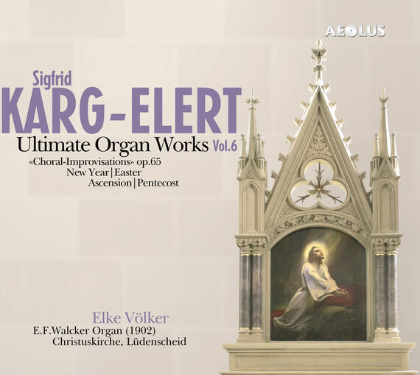

Формат записи/Источник записи: [SACD-R][OF]
Наличие водяных знаков: Нет
Год издания/переиздания диска: 2011
Издатель (лейбл): Aeolus
Жанр: Classical
Продолжительность: 01:10:00
Наличие сканов в содержимом раздачи: Только обложка альбома

Треклист:
Sigfrid Karg-Elert (1877-1933)
1. Allein Gott in der Höh sei Ehr G major [op.65,23] - 04:13
2. Dir, dir Jehova, will ich singen C major [op.65,24] - 02:34
3. Erschienen ist der herrlich Tag E minor [op.65,25] - 01:32
4. Jesu, hilf siegen, du Fürste des Lebens A major [op.65,26] - 03:23
5. Jesus, meine Zuversicht C major [op.65,27] - 05:26
6. Lobe den Herren, o meine Seele B flat major [op.65,28] - 03:01
7. Machs mit mir, Gott, nach deiner Güt E flat major [op.65,29] - 01:39
8. Nch einer Prüfung kurzer Tage D major [op.65,30] - 02:50
9. Nun laßt uns Gott dem Herren B flat major [op.65,31] - 03:33
10. Ringe recht, wenn Gottes Gnade F major [op.65,32] - 01:25
11. Wachet auf, ruft uns die Stimme C major [op.65,33] - 05:07
12. Ach Gott und Herr B flat major [op.65,34] - 02:36
13. Gott des Himmels und der Erden A major [op.65,35] - 02:47
14. Herr, wie du willst A major [op.65,36] - 03:53
15. Ich danke dir, lieber Herre A major [op.65,37] - 02:54
16. Jesu, meine Freude D minor [op.65,38] - 05:28
17. Komm, heiliger Geist, Herre Gott G major [op.65,39] - 02:33
18. O daß ich tausend Zungen hätte G major [op.65,40] - 05:19
19. O Durchbrecher aller Bande E flat major [op.65,41] - 02:37
20. O Ewigkeit, du Donnerwort E flat major [op.65,42] - 02:48
21. O Gott, du frommer Gott [ F major [op.65,43] - 03:01
22. Wie schön leucht’ uns der Morgenstern F major [op.65,44] - 01:53

Personnel:
Elke Völker - E.F.Walcker organ (1902)
Контейнер: ISO (*.iso)
Тип рипа: image
Разрядность: 64 (2,8 MHz/1 Bit)
Формат: DSD
Количество каналов: 2.0, 5.0
Original Recording Format: PCM
Источник (релизер): WEB.
AE10721 Karg-Elert, Sigfrid Ultimate Organ Works Vol.6 / All Discs / AEOLUS - aeolus-music.com

Доп. информация:
Label: Aeolus
EAN 4026798107215
Release Date: 17/12/2011
Recording location: Christ Church in Lüdenscheid
Original Recording Format: PCM
Recording Type & Bit Rate: DSD64

Об альбоме (сборнике)
Lüdenscheid, Christuskirche
The organ of the Christ Church in Lüdenscheid was built by E.F.Walcker in 1902 as opus 1035.
Designed by the architect Gustav Adolf Fischer of Barmen and built under his direction the Christ Church in Lüdenscheid was inaugurated on Oct 31, 1902 after approximately two and a half years of construction. With almost 1200 seats, the building is the largest church in the Mark Brandenburg district. The floor plan is based on a Greek cross. In the middle of this cross, the room expands to a large dome which is 16.5 m high.
The name of Christ Church is manifested through the appearance of the three offices of Jesus: outside of the church at the tower above the main entrance stands the figure of the teaching Prophet. The altar picture shows Jesus suffering at Gethsemane for the sins of the people and in the round window above the altar we can see the death conquering Risen, who is surrounded by the angels of the choir vault.
Since 1980, the building is designated a historic monument. Apart from some small changes it is still preserved in its original state.
On the day of the church’s consecration the new organ built by the E.F.Walcker company from Ludwigsburg - a 36 stop instrument with pneumatic cone valves - could be heard for the first time. On November 1, 1902 the “Lüdenscheid Newsweek” wrote: “Now the majestic sounds of the new organ roared with power through the church.”
In 1917, the original high-quality tin front pipes had to be delivered for war purposes to the army administration. It was only after the monetary stabilization in 1924, that new front pipes could be installed, but these were made from less expensive zinc.
In April 1945 the church was heavily damaged through the bombardment of the allied army and could not be opened for the community until the Reformation Day in 1948. Even though the organ was not directly hit, it was for a longer time exposed to the mercy of the weather. The organ builder Bernard Koch repaired the instrument in the late 1940s. The same company was contracted in 1957 with the modernization of the organ. The conversion to electrical action came along with a modification of the instrument’s caracter into neo baroque style following the purposes of the Orgelbewegung.
On the occasion of the church renovation for the 100th anniversary in 2002, the question about the restoration of the Walcker organ came up again, as different organ experts had always attested monument qualities to this instrument.
In 2006 the parish signed a contract with the company Gebr. Stockmann (Werl) for the restoration.
The following measures were taken:
- restoration of the organ case, the windchest, the blower system and the original pipes,
- replacement of all pneumatic components,
- re-establishment of the stop list of 1902 and reconstruction of the pipework having disappeared in 1957 based on original scales from the Walcker company,
- reconstruction of the console design,
- modernization of the retained electric action,
- expansion of the pedal from 27 to 30 keys,
- addition of sub and super octave couplers,
- installation of a modern combination system (4000 spaces).
The rededication of the organ took place on the 3rd Sunday of Advent 2008.

About AEOLUS
AEOLUS is a record label specializing in Baroque Music and music for organ. Our goal, and that of our artists, is to present superb interpretations performed on the most appropriate instruments. In order to achieve this, we often travel throughout Europe to record rare historical instruments.
We also strive to attain the best results in terms of sound quality. In pursuit of this goal, we record very carefully in well-chosen venues with the best possible recording equipment. Often our recordings are released on Super Audio CDs, providing high-end stereo as well as surround sound on SACD players, while offering full compatibility with all standard CD players.
AEOLUS is based in Germany, and run by the producers Christoph M. Frommen and Ulrich Lorscheider.

