Mahler - Symphony No.4
Tokyo Metropolitan Symphony Orchestra, Eliahu Inbal

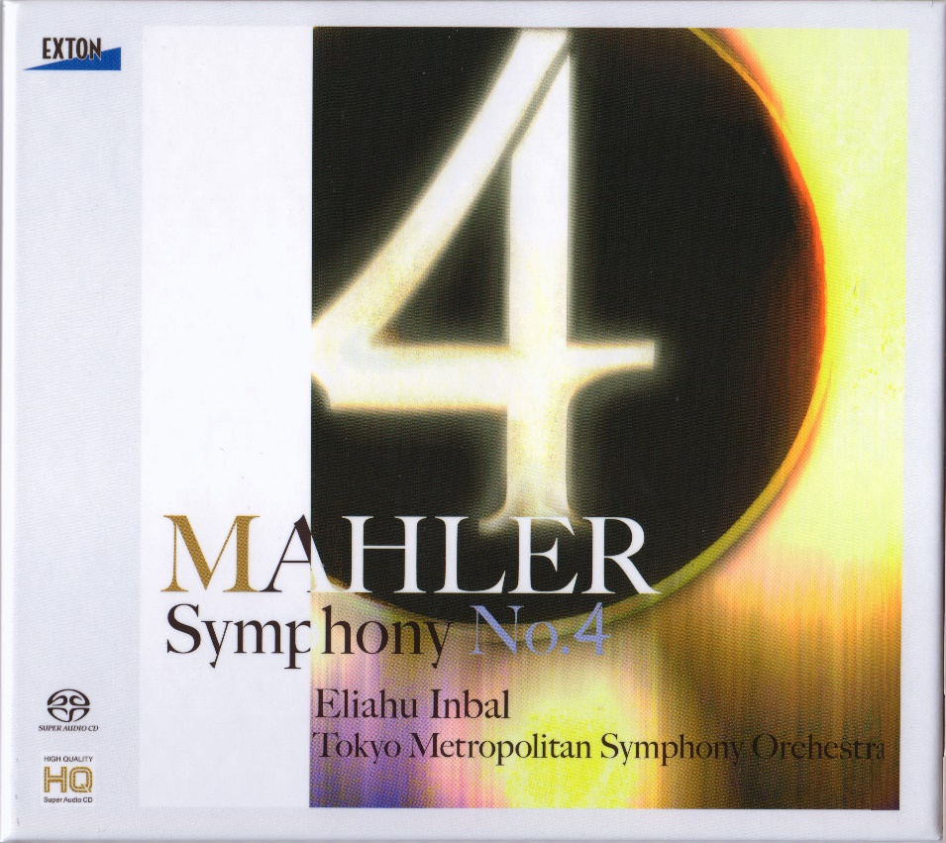

Формат записи/Источник записи: [SACD-R][OF]
Наличие водяных знаков: Нет
Год издания/переиздания диска: 2012
Издатель (лейбл): EXTON (Japan)
Жанр: Classical
Продолжительность: 00:52:25
Наличие сканов в содержимом раздачи: да
Треклист:
01 - 1st movement - Bedächtig, nicht eilen (deliberate, unhurried) - 16:00
02 - 2nd movement - In gemächlicher Bewegung, ohne Hast (in measured tempo, unhurried) - 09:25
03 - 3rd movement - Ruhevoll, poco adagio (calm, somewhat slowly) - 18:37
04 - 4th movement - Sehr behaglich (at ease) - 09:03

Personnel:
Tokyo Metropolitan Symphony Orchestra
Eliahu Inbal, conductor
Maki Mori, soprano

Контейнер: ISO (*.iso)
Тип рипа: image
Разрядность: 64 (2,8 MHz/1 Bit)
Формат: DSD
Количество каналов: 2.0
Original Recording Format: DSD64
Источник (релизер): WEB.
SA-CD.net - Mahler: Symphony No. 4 - Inbal

Доп. информация:
Label: Exton Laboratory
OVCL-00514
Recording Date: 3,4 November 2012
Recording Location: Tokyo Metropolitan Theatre, Yokohama Minato - Mirai Hall
Original Recording Format: DSD64

Об альбоме (сборнике)
The Symphony No. 4 in G major by Gustav Mahler was composed from 1899 to 1900, though it incorporates a song originally written in 1892. That song, "Das himmlische Leben (Heavenly life)", presents a child's vision of heaven and is sung by a soprano in the symphony's Finale. Both smaller in orchestration and shorter in length than Mahler's earlier symphonies, the Fourth Symphony was initially planned to be in six movements, alternating between three instrumental and three vocal movements. The symphony's final form-begun in July 1899 at Bad Aussee and completed in August 1900 at Maiernigg-retains only one vocal movement (the Finale) and is in four movements: Bedächtig, nicht eilen (sonata form); In gemächlicher Bewegung, ohne Hast (scherzo and trio); Ruhevoll, poco adagio (double theme and variations); and Sehr behaglich (strophic variations).

Reviews:
5.0 out of 5 stars Everything is recorded in great detail, also Inbal's occasional humming along.
Reviewed in the United Kingdom on 9 May 2016
This hybrid sacd (on audiophile label Exton) contains Inbal's third recording of this symphony.
Mahlerites will be familiar with his 1985 recording on Denon with the FRSO and soprano Helen Donath. (runtime 56:25)
This 4th was considered by many to be the high point of his first Mahler cycle.
Years later, between 2008-2012, maestro Inbal embarked on a second Mahler cycle with Japanese label Exton recording symphonies with both the
Czech Philharmonic Orchestra and the Tokyo Metropolitan Symphony Orchestra.
The 4th in this cycle was recorded live on nov 19th 2009 with the Tokyo Metropolitan Symphony Orchestra and soprano Miwako Handa.
(runtime 54:45)
Inbal's second cycle for Exton never reached conclusion; lacking 6th, 9th & 10th symphonies. (But including Das Lied)
However, between 2012-2014, Inbal started a third Mahler cycle (also, for Exton). For this cycle all symphonies were recorded with the Tokyo Metropolitan Symphony Orchestra. (So far symphonies 1 - 10 have been released; with only Das Lied lacking this time.)
This time soprano Maki Mori sings Das Himmlische leben and Inbal conducts the 4th symphony at a fast clip. (runtime 52:25)
He only takes 18:37 for the slow movement which was a pleasant eye opener to me. (I always was of the opinion that this symphony somehow ran out of steam in the 3rd slow movt. - not so here.) Comparable to the way the 5th symphony adagietto nowadays is performed at a faster clip than on older recordings.
Exton is a label which is renowned for its sound quality. Everything is recorded in great detail, also maestro Inbal's occasional humming along to the music.
I could not live with only one Mahler 4th in my collection. (I own 11 recordings of it) But this Nov. 2012 recording by Inbal and the TMSO and Maki Mori is always near my top of my M4 pile.
Helpful

4.0 out of 5 stars #4 is a pretty difficult song
Reviewed in Japan on 7 February 2020
I listened to the second movement and felt it was a very sympathetic performance. No, the 2 movement is more than expected. Compared to what I've been listening to, I wanted to get a little nostalgic to play the third movement, but I think this is good for modern performance. Fourth movement, this is a soprano that I have never heard in number 4 before, so personally I couldn't seem to fit this lyrics. It was a pity for me that vibrato also listened to this music unnaturally. It might be better for me to have some brainweather do it. I just listened to today and are my impressions now. When you listen again, you may have a somewhat different impression again. I had a slightly negative impression because the expectations were too big from the number of acquiring ☆ so far. But there is no doubt that it's a great performance for ☆ 4.5.

5.0 out of 5 stars Super real sound quality!
Reviewed in Japan on 14 November 2015
This is the first time ever realistic number 4.
I'm really happy!
I was listening to Bernstein's Gramophone board until now, but I got tired of listening, so I bought this one.

5.0 out of 5 stars Universal starring
Reviewed in Japan on 8 October 2013
I think number 4 is a work that perfectly matches the qualities of Inbal among Mahler's symphonies.
It expresses the classical uniform texture very accurately, and is also captivated by the beauty of the strings of Tokyo Hibiki.
Especially the 3 movements are great.
It can be recommended as a standard performance.
Recording is good, but if you say greed, you may have a bit more reverberation.

