Frank Martin - Concertos
Michael Erxleben, Orchester Musikkollegium Winterthur
Jac van Steen (conductor)
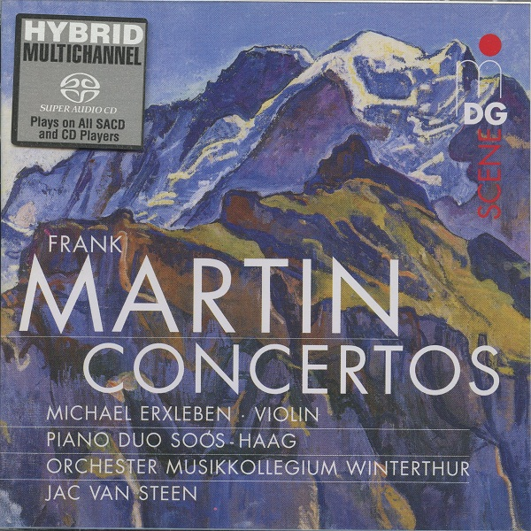

Формат записи/Источник записи: [SACD-R][OF]
Наличие водяных знаков: Нет
Год издания/переиздания диска: 2004
Издатель (лейбл): MDG Scene
Жанр: Classical
Продолжительность: 01:04:20
Наличие сканов в содержимом раздачи: Только обложка альбома

Треклист:
Frank Martin (1890-1974)
Violin Concerto
1. Allegro tranquillo - 12:34
2. Andante molto moderato - 10:10
3. Presto - 06:46
Concerto for 7 wind instruments (timpani, percussion & string orchestra)
4. Allegro - 06:40
5. Adagietto - 06:40
6. Allegro vivace - 07:18
7. Danse de la Peur, for 2 pianos & small orchestra (from the ballet "Die blaue Blume") - 14:17

Personnel:
Michael Erxleben (violin)
Adrienne Soós and Ivo Haag (piano duo)
Orchester Musikkollegium Winterthur
Jac van Steen (conductor)
Контейнер: ISO (*.iso)
Тип рипа: image
Разрядность: 64 (2,8 MHz/1 Bit)
Формат: DSD
Количество каналов: 2.0, 5.1
Original Recording Format: PCM (2+2+2 system)
Источник (релизер): WEB.
SA-CD.net - Martin: Concertos - Jac van Steen

Доп. информация:
Label: MDG Scene
MDG 601 1280-2
Release Date: November 15, 2004
Recording date and location: 23 October 2003 (Concerto for seven wind instruments); 15-17 January 2004 (Violin Concerto, Danse), Stadthaus, Winterthur.
Original Recording Format: PCM (2+2+2 system)
Recording Type & Bit Rate: DSD64

Об альбоме (сборнике)
Frank Martin (pronounced, in the French way, Frahnk Mar-TAN) has a complex artistic history. Born in Geneva, Martin (1890-1974) grew up in, at the time, a German musical culture. It took conductor Ernest Ansermet to introduce and establish French composers in Swiss concert repertory. Martin's earliest music reflected German taste, especially a life-long inspiration of J. S. Bach. He eventually became one of the great composers of sacred music in the Modern era. By the Twenties, however, he had accommodated French Impressionist harmony into his language without ever quite becoming an Impressionist. Martin had no formal training as a composer. He worked on his own, and he kept his independence throughout his life. For example, he became interested in certain ideas of Arnold Schoenberg but never went over to atonality. He remained steadfast in his belief in harmony as the strongest musical element. Over the years, his idiom changed several times, which makes him hard to classify, something that may account for his relative neglect among musicologists. Nevertheless, great musicians continue to program his music.

The Swiss composer Frank Martin travelled widely throughout Europe, gaining a rich awareness of prevailing musical styles, and these experiences had a strong influence on his approach to composition. Maurice Ravel was probably the contemporary figure with whom he felt the closest affinity, and Bach the master for whom he had the greatest reverence.
The collection gathered here makes a compelling combination. These three concertante pieces each bring their own particular slant on the medium. To a large extent this is because the performing resources required are so different from one piece to the next. But in each case Martin shows his mastery of the musical demands.
The earliest of these pieces is Danse de la peur, of 1936. This is a single movement composition, for two pianos and small orchestra. The dynamic range is wide, so too the range of tempi. While the ensemble is described as a ‘small orchestra’, there is no lack of variety, and the music certainly packs a punch. The recorded sound is excellent, as it is in the other pieces.
The Concerto for seven wind instruments, timpani, percussion and strings dates from 1949 and adopts the traditional three-movement plan. There are plenty of different instrumental colours and combinations, of course, and Martin exploits these various options with both imagination and rhythmic freedom. With seven solo wind instruments the choices of priority are numerous; so much to that this becomes a most unconventional concerto, a kind of concerto for orchestra minus the string section. Be that as it may, the results are compelling, with excellent opportunities shared around the ensemble.
There are three movements, each of some seven minutes, on the conventional fast-slow-fast design. All praise to the members of the Musikcollegium Winterthur, whose performance is fresh, spontaneous, and virtuoso too.
On the face of it, the Violin Concerto of 1951 is the most traditional of these three pieces, since it has a three-movement plan and a more conventional relationship between solo and ensemble. As the music evolves, so it becomes evident that Martin has adapted these procedures in his own way. For instance, the recapitulation of the first movement’s principal themes comes not within that movement but later in the work, as if to set the seal of unity on the whole conception. Moreover, the third theme becomes the basis of the passacaglia that lies at the heart of the second movement, while the second theme is treated fugally in the development section that lies at the heart of the finale. Does all this sound too clever by half? If it does, do not be fooled; for the music sounds fresh and spontaneous in every bar.
The Violin Concerto, in common with the distinctive masterpieces associated with Martin’s genre, is a particularly poetic work. It is appropriate therefore that Michael Erxleben makes a compelling soloist, at once lyrical and strong, as the score demands.
Terry Barfoot - http://www.musicweb-international.com/

Reviews:
Review by Graham Williams - November 8, 2005
Performance: 5, Sonics (Stereo): 5, Sonics (Multichannel): 5
Comparatively little of the considerable output of the Swiss composer Frank Martin (1890-1974) is available on CD, so this SACD from the enterprising MDG is especially welcome.
Although Martin became interested in the serial technique of Arnold Schönberg in the 1930s, he adapted and incorporated it into his own musical style, which remained essentially tonal.
The three works on this disc were written between 1937 and 1951/2 and are representative of his many compositions for solo instruments, or instrumental groups, and orchestra.
The longest piece here is the Violin Concerto of 1950 (29m 13s), a fascinating and major work that should be better known, particularly if it were performed as well as here by the excellent soloist Michael Erxleben. The cadenza, two-thirds through the first movement, illustrates the quality and virtuosity of his playing.
The second movement is a lyrical, but melancholic, andante and the short Presto finale allows the soloist much opportunity for display. The whole piece is beautifully constructed and imaginatively orchestrated.
The Concerto for seven wind instruments, timpani, percussion and strings (1949) is more familiar through a number of previous recordings, but none that I have heard are as well performed and recorded as this one.
The seven wind soloists are laid out clearly across and in front of the orchestra and the conductor Jac van Steen moves the piece forward with an engaging lightness of touch. The haunting second movement with its rhythm reminiscent of a slow funeral march, or a ticking clock, is particularly well managed and remains insistent in one’s mind long after one has finished listening, while the boisterous finale gives the soloists, including the superb timpanist, the opportunity to shine.
The final work Danse de la peur (1937) for two pianos and small orchestra, grippingly played by the duo Soós, was originally composed as part of an aborted ballet ‘The Blue Flower’ for Zurich Ballet and was premiered in its revised form by Dinu Lipatti and his wife in 1944.
It begins with a slowly and mysteriously, then a short central section for pianos and percussion follows that leads to an exciting allegro. Its dance origins seem clear and it reminds me somewhat of Bartok’s 1st piano concerto in its use of percussion and the percussive qualities of the two pianos.
MDG have provided a recording of truly outstanding quality for this SACD.
The dynamic range is wide and it is a model of clarity. The solo instruments and orchestra are beautifully balanced - no mean feat - within the sympathetic acoustic of the Stadthaus Wintherthur. The subtle use of the rear channels adds further to the sense of realism while MDG’s 2+2+2 system is available for those who wish to try the height channels option.
As usual with MDG, the booklet notes are detailed, authoritative and most helpful to the listener. Highly recommended.

Frank Martin: Concertos Review by Blair Sanderson
Even though Frank Martin at times experimented with Schoenberg's twelve-tone system, he used the row merely as a modification of his already flexible tonal language. As a result, his Violin Concerto (1950-1951) is smooth and fluid as it drifts between its chromatic, dissonant counterpoint, and overtly tonal passages, for these are derived from the same interval relationships. Most notable about this Concerto, however, is the integral role the violin plays. Martin eschewed virtuosity for its own sake, and reasoned that the solo part must always be an extension of the whole work's material and development, not just an endless cadenza with accompaniment. Consequently, violinist Michael Erxleben has comparatively few opportunities to display his fine technical skills, and must instead let his tone and expression carry the piece along. The polished Orchester Musikkollegium Winterthur, conducted by Jac van Steen, is solidly behind Erxleben, and the soloist and orchestra seem evenly balanced in MDG's natural, unprocessed recording. The fairly comical Concerto for 7 wind instruments, timbales, percussion and string orchestra (1949) and the quasi-Impressionistic ballet piece Danse de la peur for two pianos and small orchestra (1936) are pleasant to hear for their vibrant colors, but are perhaps less intellectually and emotionally stimulating than the Violin Concerto.

