Mendelssohn – Piano Trios Nos.1&2
Julia Fischer, Daniel Muller-Schott, Jonathan Gilad
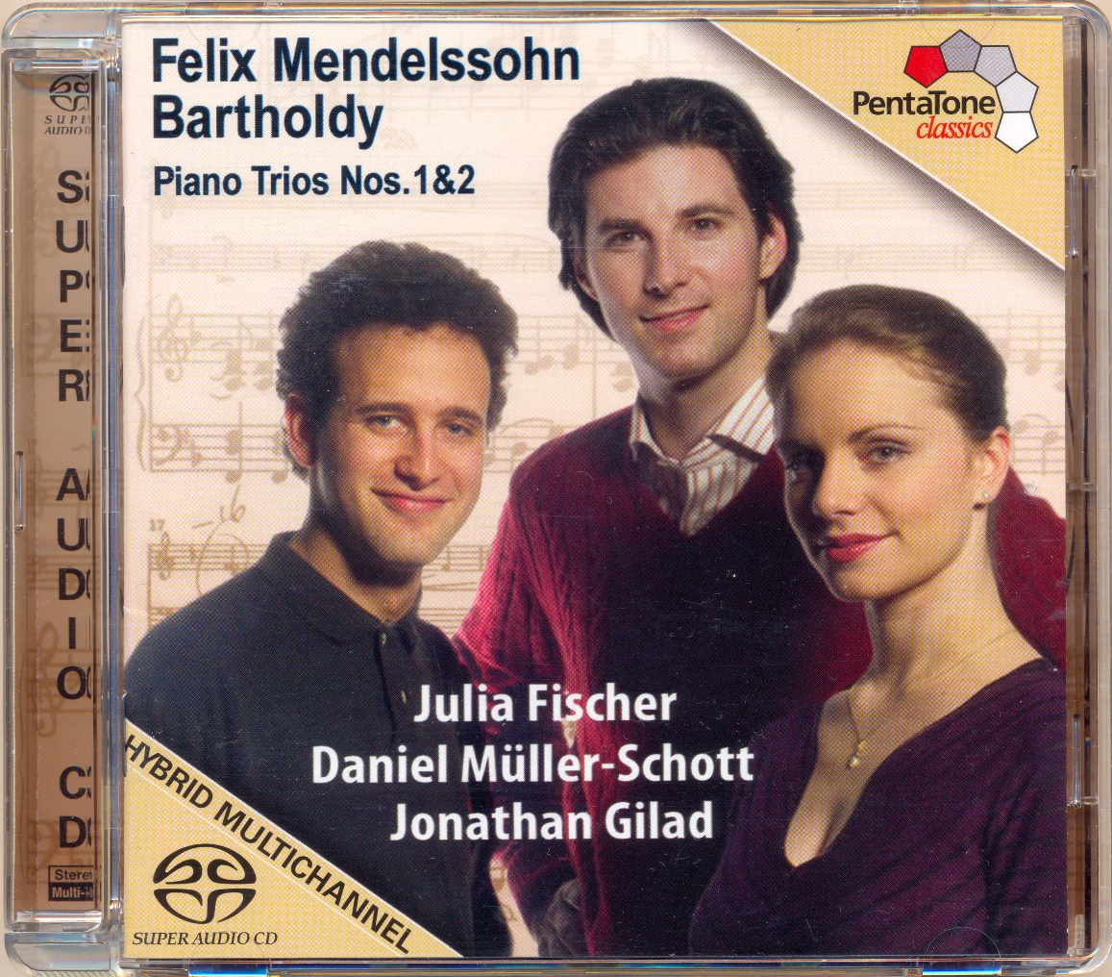

Формат записи/Источник записи: [SACD-R][OF]
Наличие водяных знаков: Нет
Год издания/переиздания диска: 2015
Издатель (лейбл): PentaTone Classic
Жанр: Classical
Продолжительность: 00:59:01
Наличие сканов в содержимом раздачи: да
Треклист:
1. Piano Trio No. 1 in D minor, Op. 49 - Molto allegro agitato - 09:41
2. Piano Trio No. 1 in D minor, Op. 49 - Andante con moto tranquillo - 06:58
3. Piano Trio No. 1 in D minor, Op. 49 - Scherzo - Leggiero e vivace - 03:31
4. Piano Trio No. 1 in D minor, Op. 49 - Finale - Allegro assai appassionato - 08:30
5. Piano Trio No. 2 in C minor, Op. 66 - Allegro energico e con fuoco - 10:41
6. Piano Trio No. 2 in C minor, Op. 66 - Andante espressivo - 08:17
7. Piano Trio No. 2 in C minor, Op. 66 - Scherzo - Molto allegro quasi presto - 03:26
8. Piano Trio No. 2 in C minor, Op. 66 - Finale - Allegro appassionato - 07:57

Personnel:
Julia Fischer - violin
Daniel Muller-Schott - cello
Jonathan Gilad - piano

Контейнер: ISO (*.iso)
Тип рипа: image
Разрядность: 64 (2,8 MHz/1 Bit)
Формат: DSD
Количество каналов: 2.0, 5.0
Original Recording Format: DSD64
Источник (релизер): WEB.
The Piano Trios - NativeDSD Music

Доп. информация:
Label: Pentatone
SKU PTC5186085
Release Date: May 16, 2015
Recording location: Deutschlandfunk Sendesaal, Cologne, Germany, February 14-16, 2006
Original Recording Format: DSD64
Recording Type & Bit Rate: DSD64

Об альбоме (сборнике)
Classical moderation and Romantic sensitivity are the signatures for the music of Felix Mendelssohn Bartholdy. Not, however, in an anachronistic, but in a progressive sense of the word, even transgressing boundaries: “Nobody can forbid me to take pleasure in this and to continue working on the legacy left to me by the great masters. After all, it is not the idea that each person has to start afresh from the beginning; however, the work should also carry on from where it left off in accordance with one’s creative powers, and not be solely an unimaginative repetition of what has been”, thus did he formulate his self-confident, aesthetic concept. And correspondingly, as most of his contemporaries including Franz Liszt agreed, he thus became one of the “most outstanding German composers” of the early 19th century.

Review:
SA-CD.Net
This must be one of the best discs of chamber music making I have ever heard and certainly one of the best recorded. It certainly completely eclipses all other versions of this wonderful music I have heard. Rarely has any chamber music sounded so lifelike.
The quality of the playing and the feeling is recalled of when I first heard Multichannel but I am now regularly “immersed” in beauty. So this is really something very special indeed. Tremendously exciting!
Do not hesitate – buy this for yourself and anyone you know who loves chamber music as, even in “plain” stereo, you & they will surely love it as much as I do.
John Broggio

