Mozart - Serenades and Divertimenti
Camerata Salzburg, Sandor Vegh
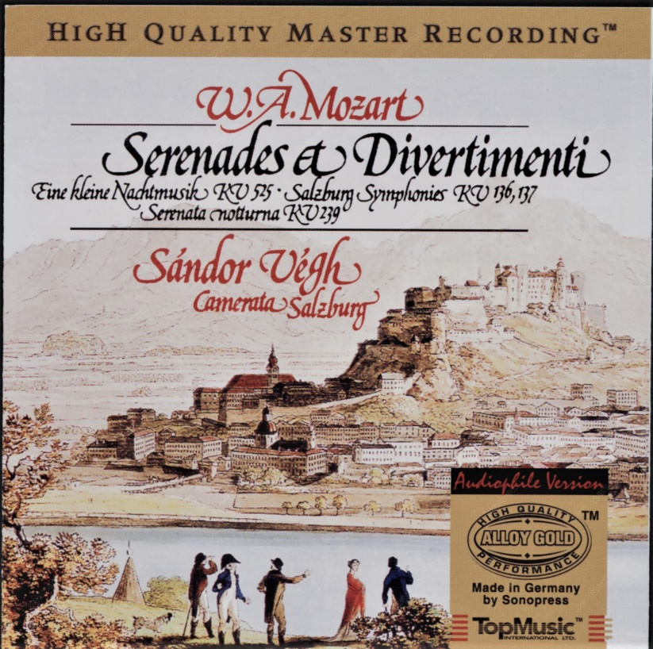

Формат записи/Источник записи: [SACD-R][OF]
Наличие водяных знаков: Нет
Год издания/переиздания диска: 2003
Издатель (лейбл): Capriccio
Жанр: Classical
Продолжительность: 00:51:00
Наличие сканов в содержимом раздачи: Только обложка альбома

Треклист:
Serenade No.13 In G Major for String Kv 525 "Eine Kleine Nachtmusik"
1. Allegro - 5:34
2. Romance, Andante - 6:40
3. Menuetto, Allegretto - 2:10
4. Rondo, Allegro - 2:49

Divertimento for String in B Flat Major Kv 137 (125b) "Salzburg Symphony No.2"
5. Andante - 2:38
6. Allegro Di Molto - 5:21
7. Allegro Assai - 2:04

Divertimento for String in D Major Kv 136 (125a) "Salzburg Symphony No.1"
8. Allegro - 4:07
9. Andante - 5:49
10. Presto - 2:43

Serenade No.6 in D Major for String and Timpani Kv 239 "Serenata Notturna"
11. Marcia. Maestoso - 2:55
12. Menuetto - 3:47
13. Rondeau. Allegro - 4:44
Personnel:
Camerata Academica Salzburg
Sandor Vegh
Контейнер: ISO (*.iso)
Тип рипа: image
Разрядность: 64 (2,8 MHz/1 Bit)
Формат: DST64
Количество каналов: 2.0, 5.1
Original Recording Format: PCM
Источник (релизер): WEB.
SA-CD.net - Mozart: Serenades and Divertimenti - Camerata Salzburg

Доп. информация:
Label: Capriccio 71001
Release Date: May 2003
Original Recording Format: PCM
Recording Type & Bit Rate: DSD64

Об альбоме (сборнике)
Up to and including Mozart, one important task for every composer not employed by the Church was to entertain. Much of Mozart’s best-loved music consists of occasional works intended for receptions and parties, balls and banquets, ceremonies and celebrations. These pieces are known to us under a number of different names: serenades, divertimenti, Nachtmusik and notturni are just some examples. In so far as these are genres, the distinctions between them are often blurred and many of them seem to have been used more or less interchangeably. But when the music is so fresh and immediate, labelling it becomes less important. In 1778, Leopold Mozart –who never missed an opportunity to impart his wisdom –wrote to his son describing what characterizes a successful piece: ‘Short, easy and popular… written in a natural, flowing and easy style –and at the same time bearing the marks of sound composition.

