Les Elemens - Marais and Rebel
Palladian Ensemble
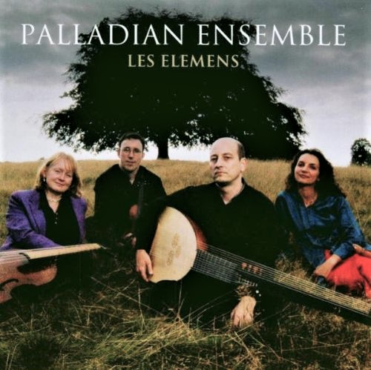

Формат записи/Источник записи: [SACD-R][OF]
Наличие водяных знаков: Нет
Год издания/переиздания диска: 2003
Издатель (лейбл): Linn Records
Жанр: Classical
Продолжительность: 01:07:36
Наличие сканов в содержимом раздачи: Только обложка альбома

Треклист:
Jean Fery Rebel (1666-1747)
Les Elemens
01. Le Cahos - 6:07
02. Air pour les violons (La Terre et L'Eau) - Chaconne (L'Air) - 4:29
03. Ramage (L'Air) - 1:23
04. Rossignolo - 1:42
05. Loure - 1:40
06. Tambourin - 2:04
07. Sicillienne - 1:34
08. Caprice - 2:33

Marin Marais (1656-17280
Suite in A Minor
09. Prelude - 3:13
10. Fantasie - 4:13
11. Tombeau de Mr Meliton - 7:03
12. Rondeau moitié pincé et moitié coup - 3:56
13. Chaconne - 6:16

Suite in G major
14. Sarabande grave - 3:05
15. Le petit badinage - 1:43
16. Rondeau le Troulleur - 3:53

17. Folies d'Espagne - 14:31

Personnel:
The Palladian Ensemble:
Pamela Thorby - recorders
Rachel Podger - violin
Susanne Heinrich - viola da gamba
William Carter - theorbo, guitar
Контейнер: ISO (*.iso)
Тип рипа: image
Разрядность: 64 (2,8 MHz/1 Bit)
Формат: DST64
Количество каналов: 2.0, 5.1
Original Recording Format: PCM
Источник (релизер): WEB.
Les Elemens: Marais and Rebel | Linn Records

Доп. информация:
Label: Linn Records CKD 221
Release Date: 2003
Recording location: Toddington's St Andrews church, Toddington, England
Original Recording Format: PCM
Recording Type & Bit Rate: DSD64

Об альбоме (сборнике)
A powerful performance of French baroque by Rebel and Marais from the popular Palladians.
In their first CD with violinist Rudolfo Richter, the Palladian Ensemble play the music of Marin Marais (1656 - 1728) and Jean-Féry Rebel (1666 - 1747). A suite from Les Elemens, an opera by Rebel, forms the centrepiece of the disc. The thunderous dissonance which opens Les Elemens can scarcely be believed to be by the 71-year-old Rebel, whose music had been praised for its 'Wisdom, Taste and Tenderness' and its avoidance of the 'Frightening and Monstrous'.

Palladians (formerly the Palladian Ensemble) is a quartet of the highest calibre, firmly established on the international music scene since 1991. They present baroque chamber music infused with style, uninhibited virtuosity and intelligent musicianship.
The original members of the Palladian Ensemble (Rachel Podger, Pamela Thorby, Joanna Levine and William Carter) met during their studies at the Guildhall School of Music and Drama (London) where they specialised in virtuoso chamber music of the baroque period. In 1991 they won the Early Music Centre International Young Artists' Competition, in 1992 they won the South East Arts Young Artists' Platform and by 1993 they had released their first album (An Excess of Pleasure) and made their Wigmore Hall debut.
Gamba player Susanne Heinrich replaced cellist Joanna Levine in 1995 and the Palladian Ensemble went on to tour extensively throughout the UK, South America, the US and Europe, enjoying consistent popularity with audiences and critics worldwide. They recorded six more albums on the way. By 2003 Rachel Podger decided to pursue a solo career and thus stepped in the prize-winning violinist Rodolfo Richter. The Ensemble made two more albums Les Elemens and Sonatas and Chorales - J.S. Bach.
The Palladian Ensemble's award-winning series of recordings for Linn Records have received unanimous praise. An Excess of Pleasure, A Choice Collection and Held by the Ears won the prestigious Diapason d'Or, with others winning Gramophone 'Editor's Choice' plaudits.
In 2007 Pamela Thorby left the Ensemble in order to pursue new performance opportunities. Nowadays, the Palladian Ensemble is known as "Palladians" allowing more artistic freedom for players to come and go as required, depending on the programme being performed.
In 2008 the Ensemble won a further two Diapason d'Or awards for "The London Collection: A Choice Collection / Held by the Ears" and "The Venice Collection: An Excess of Pleasure / The Winged Lion". The winning albums are part of four double albums re-issued as the Collector's Series in September 2008. These two new awards bring the Ensemble's total number of Diapason d'Or accolades to seven!

Review:
Review by John Broggio - December 31, 2007
A disc that is uneven in quality of arrangement but superb in every respect of the playing and recording throughout.
My principal and only real quibble with the arrangements is that of Les Elemens (prepared by The Palladian Ensemble); those for the two Marais suites and his Folies d'Espagne are quite superb. The world class William Carter attempts to justify their approach for Les Elemens by stating that the full score doesn't survive (it is rather a short score that has been preserved for us). These days, most have tried to recreate the impact (in a visceral as well as musical sense) that an orchestra in Rebel's time could cause; four players, no matter how good, do not simply have the weight, depth nor sheer power of sonority - or range of sounding in the recorders case - that the overwhelming opening number to Les Elemens requires. This problem continues for much of the rest of the suite although I challenge anyone to provide a more delightful performance of the final 3 movements - pure joy to the soul that makes one want to get up and dance along to the music!
Being sourced from non-orchestral compositions the Marais suites do not suffer from this issue and one’s ears revel in the wonderful playing on display (that of William Carter is especially fine) and this brings me to my other quibble - why could we not have more of this type of music? Les Elemens is just too grand a composition to present with only four players and other pieces by Rebel that are more amenable to recorder, violin, viola and theorbo/Baroque guitar could surely have been found. The playing here is indescribably good with a really addictive quality to the music making - it has been hard taking this out of the player, let alone place it back on the shelf! Perhaps the highlight is the concluding Folies d'Espagne, where the concluding variations contain some uninhibited virtuosity - this is hard to avoid giving oneself an encore...
The recording, from Toddington's St Andrews church is a very good 4.0 issue - there is no doubt of the fine spacing for the instruments and a very appealing halo of the acoustic is preserved.
Recommended for the Marais and the latter part of the Rebel.

