Ravel (arr. Barshai): Petite Symphonie à Cordes, Shostakovich (arr. Barshai): Chamber Symphony Op. 118a
Scottish Ensemble, Clio Gould
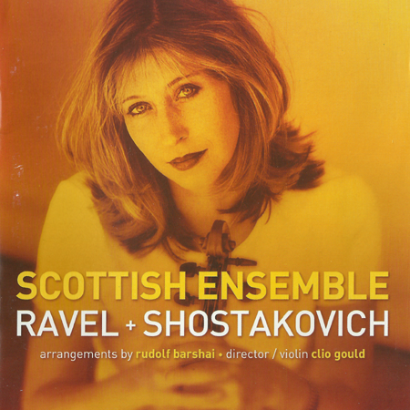

Формат записи/Источник записи: [SACD-R][OF]
Наличие водяных знаков: Нет
Год издания/переиздания диска: 2015
Издатель (лейбл): Linn Records
Жанр: Classical
Продолжительность: 01:02:54
Наличие сканов в содержимом раздачи: да

Треклист:
Ravel: Petite symphonie à cordes
1. I. Allegro moderato. Très doux (Arr. from String Quartet in F Major, M. 35) - 8:29
2. II. Assez vif, très rythmé (Arr. from String Quartet in F Major, M. 35) - 6:17
3. III. Très lent (Arr. from String Quartet in F Major, M. 35) - 8:19
4. IV. Vif et agité (Arr. from String Quartet in F Major, M. 35) - 5:04

Shostakovich: Chamber Symphony No. 5 for Strings in A flat major, Op. 118a (orch.Barshai)
5. I. Andante (Arr. from String Quartet No. 10) - 5:05
6. II. Allegretto furioso (Arr. from String Quartet No. 10) - 4:34
7. III. Adagio (Arr. from String Quartet No. 10) - 6:23
8. IV. Allegro (Arr. from String Quartet No. 10) - 8:58

Personnel:
Scottish Ensemble
Clio Gould - violin, conductor
Контейнер: ISO (*.iso)
Тип рипа: image
Разрядность: 64 (2,8 MHz/1 Bit)
Формат: DST64
Количество каналов: 2.0, 5.1
Original Recording Format: PCM
Источник (релизер): WEB.
SA-CD.net - Ravel/Shostakovich - Scottish Ensemble

Доп. информация:
Label: Linn Records CKD 215
Release Date: 16th Feb 2015
Recording location: City Halls, Glasgow, United Kingdom, 2002
Original Recording Format: PCM
Recording Type & Bit Rate: DSD64

Об альбоме (сборнике)
This is the world premiere recording of Rudolph Barshai’s arrangements of Ravel and Shostakovich string quartets.
Originally released in 2003 Ravel & Shostakovich for strings has been re-issued as part of Linn’s ECHO series which offers a second chance to enjoy the best of the label’s award-winning catalogue.
The specially commissioned arrangements retain the nuances that make the original string quartets so special but also add a whole world of subtle sonorities.
The Shostakovich quartet shows him in the prime of his creative life; Barshai's orchestration adds to the texture and depth of this piece.
The Ravel String Quartet in F major is one of director Clio Gould's favourite pieces of music so she was delighted when Rudolf Barshai agreed to orchestrate this.
Barshai, a student of Shostakovich and a founding member of the Borodin and Tchaikovsky Quartets has also completed arrangements of Shostakovich's four chamber symphonies.
Re-defining the string orchestra, Scottish Ensemble inspires audiences with vibrant and powerful performances.
Scottish Ensemble is the UK’s only professional string orchestra, built around a core of twelve outstanding string players.
The ensemble is known both in the UK and internationally for its versatility and ambitious programming.
Performing standing up, the individual layers bring an energetic and passionate dynamic to every performance.
Alongside performances across Scotland, SE presents an annual series of concerts at Wigmore Hall and has appeared at BBC Proms and the Edinburgh International, City of London, Aldeburgh and St Magnus festivals.

