Josef Rheinberger – Two Concertos for Organ & Orchestra
E. Power Biggs – organ, Columbia Symphony Orchestra
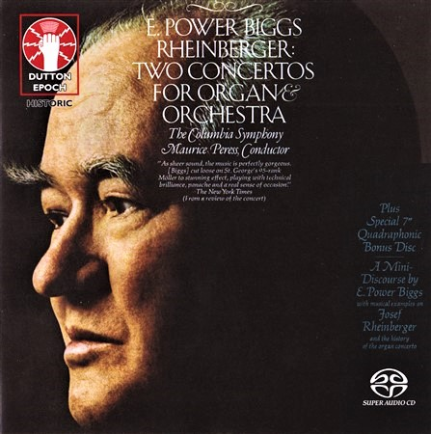

Формат записи/Источник записи: [SACD-R][OF]
Наличие водяных знаков: Нет
Год издания/переиздания диска: 2017
Издатель (лейбл): Dutton Epoch
Жанр: Classical
Продолжительность: 00:55:32
Наличие сканов в содержимом раздачи: Только обложка альбома

Треклист:
Josef Rheinberger (1839-1901)
Concerto in F Major for Organ, String Orchestra and Three Horns, Op. 137
1. I – Maestoso - 8:08
2. II – Andante - 7:53
3. III - Con Moto - 8:29
Concerto in G Minor for Organ, String Orchestra, Two Trumpets, Two Horns and Timpani, Op. 177
4. I – Grave - 8:22
5. II – Andante - 7:16
6. III - Con Moto - 7:06

E. Power Biggs - A Mini-Discourse
7. Part 1 - 5:01
8. Part 2 - 3:37

Personnel:
E. Power Biggs - Möller organ
Columbia Symphony Orchestra
Maurice Peress - conductor

Контейнер: ISO (*.iso)
Тип рипа: image
Разрядность: 64 (2,8 MHz/1 Bit)
Формат: DST64
Количество каналов: 2.0, 5.1
Original Recording Format: Original stereo and quadraphonic analog tapes
Источник (релизер): WEB.
E. Power Biggs, Rheinberger – Two Concertos For Organ & Orchestra (2017, SACD) - Discogs

Доп. информация:
Label: Dutton Epoch – CDLX 7334
Release Date: Jan 2017
Recorded at St. George's (Episcopal) Church, New York, 28-29 November, 1973 on the Möller organ
Original Recording Format: Contains the complete original stereo and quadraphonic mixes of the album "Rheinberger: Two Concertos for Organ & Orchestra" M/MQ 32297 (1973) and the accompanying 7" EP "A Mini-Discourse by E. Power Biggs" BTQ 32.
Recording Type & Bit Rate: Remastered from original analogue tapes to DSD64

Об альбоме (сборнике)
This splendid Dutton SACD, licensed from Sony, contains two organ concertos by Joseph Rheinberger. The concertos are among the finest ever composed for this instrument. Rheinberer included brass soloists and timpani as well as an orchestra. E. Power Biggs is featured along with the Columbia Symphony directed by Maurice Peress, recorded in St. George’s Episcopal Church in New York November 28-29, 1973 on the grand Möller organ. For this reissue, the producers used great imagination taking full advantage of the four channels, separating the instruments most effectively. The equipment indicates that this is a 5.1 recording, which seems rather odd as this was a four-track recording. At any rate, the result is a treat for those who care about quality sound, a thrilling audio experience.

