Schubert - Sonata in B flat major & Moments Musicals
Dejan Lazic - piano
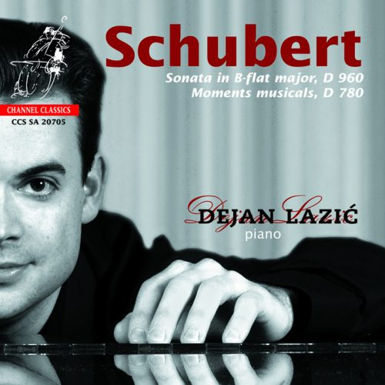

Формат записи/Источник записи: [SACD-R][OF]
Наличие водяных знаков: Нет
Год издания/переиздания диска: 2014
Издатель (лейбл): Channel Classics
Жанр: Classical
Продолжительность: 01:11:21
Наличие сканов в содержимом раздачи: да
Треклист:
1. Sonata In B-Flat Major, D 960 (Op. Posth.) - Molto Moderato - 20:31
2. Sonata In B-Flat Major, D 960 (Op. Posth.) - Andante Sostenuto - 09:54
3. Sonata In B-Flat Major, D 960 (Op. Posth.) - Scherzo. Allegro Vivace Con Declicatezza - 03:54
4. Sonata In B-Flat Major, D 960 (Op. Posth.) - Allegro Ma Non Troppo - 08:55
5. Moments Musicals, D 780 (Op. 94) - No. 1 In C Major – Moderato - 05:48
6. Moments Musicals, D 780 (Op. 94) - No. 2 In A-Flat Major – Andantino - 05:33
7. Moments Musicals, D 780 (Op. 94) - No. 3 In F Minor - Allegro Moderato - 01:51
8. Moments Musicals, D 780 (Op. 94) - No. 4 In C Sharp Minor – Moderato - 06:07
9. Moments Musicals, D 780 (Op. 94) - No. 5 In F Minor - Allegro Vivace - 02:08
10. Moments Musicals, D 780 (Op. 94) - No. 6 In A Flat Major – Allegretto - 06:40

Personnel:
Dejan Lazic - piano

Контейнер: ISO (*.iso)
Тип рипа: image
Разрядность: 64 (2,8 MHz/1 Bit)
Формат: DSD
Количество каналов: 2.0, 5.0
Original Recording Format: DSD64
Источник (релизер): WEB.
Sonata in B flat major & Moments Musicals - NativeDSD Music

Доп. информация:
Label: Channel Classics
SKU 20705
Release Date: March 1, 2014
Recording locations: Eindhoven, The Netherlands
Recording date: January 2004
Original Recording Format: DSD 64
Recording Type & Bit Rate: DSD64

Об альбоме (сборнике)
One of the hardest questions for a musician to answer is Who is your favorite composer? Personally, I have often been asked this question, but I was never able to limit myself to a single composer. I came very close to choosing one, however, during my preparations for this CD, in fact very close indeed. For all that this choice may appear to be forced, subjective, and of a temporary nature, it is not. Not when one thinks of how many extraordinary piano and chamber music works, songs and symphonies Franz Schubert created during his all-too-brief life. This way of thinking sheds a different light on the choice, and justifies it. Nevertheless, Schubert avoided two larger forms: the opera and the concerto. The reasons for this could have included his character, which was in part deeply introverted, as well as his distaste for virtuosity, which he saw as a kind of exhibitionism of the soloist in front of the orchestra which accompanied him; in the same way, the frequently banal or superficial libretti of operas may have put him off. In no way did this indicate a lack of dramatic ability, for his music is not only exciting, but goes far beyond, it penetrates deeply into the listener’s senses. He lived in an unusual time. He lived in the interval between the Viennese Classical Style and Romanticism, in a world which was stylistically completely new, different, and exceptional. His music is characterized by the clarity of its form and the complexity of its structures: often it is so subtly conceived that one can distinguish paper-thin layers of differing inspiration….

Reviews:
Piano News
The great B flat major Sonata turns into a mystical adventure under his fingers (...) (...) here is a magician with the consciousness for Schubert's thoughtfulness, his sensitive soul but also for his humor at work, which ones.

Fono forum
Dejan Lazic: highly sensitive Schubert lyric poet () () There has a very good conversation about the fragile, pure soul structure of this music and evokes its conceal vitality and its infinite breath through a highly different from the quiet. (...)

Piano world
This young dog shows that he has more to offer than just a frisky puppy, but I didn't think he would turn out like this. The contrast is astounding. Kudos to anyone who, on the basis of Lazic's earlier performances, would blindly ascribe this Schubert play to this pianist.

Brabants Dagblad
Only a child prodigy can achieve these tricks, Lazic is of that kind, he has the right sensitivity and can empathize like no other in the intention of this composer (…) Brabants Dagblad

ClassicsToday. France
a performer visibly endowed with a great personality (...) he astonished me his richness of touch, his faculty of laying down the notes with tenderness. Its first part finds a real breathing and pulsation, where some great ones appear static (… very nice CD on the technical and interpretative level.

Haagsche Courant
the young Dejan Lazic is clearly looking for his own way. In fact, he seems to want to break away from the established tradition, by repeatedly defying listening expectations. (…) That already starts in the first part. The lyrical opening theme, which sets the tone for a long, very veiled, soft-focus atmosphere, giving way to a series of experiments: studies of pedal use, the highlighting of normally unexposed accompaniment figures, but above all; the game with the rhythm. No two notes are alike. Time and again Lazic tries to magnify certain rhythmic patterns by lengthening notes, taking rhythms out of context or otherwise putting them in a new light. At first this is alienating and sometimes even irritating, but in the course of the piece this strangeness gives way to fascination, especially because Lazic consistently maintains his 'whims'. A discovery for anyone who thinks they are more or less familiar with this sonata by now. (…) (…) In the 'Moments Musicals' the pianist felt less urgency for rhythmic innovation, so that the emphasis is more on the musical narration itself. Avro website Lazic has something to say

BN/the Voice
Dejan Lazic approaches 'his' Schubert in a way that grabs me from the heart. He does this with a power of persuasion that does not go unnoticed. () www.audio.muziek.nl (…) The atmosphere of Schubert's music is expertly highlighted. (…) (…) Dejan Lazic has rightly built up a great reputation in a short time and lives up to it. (…) (…) Highly recommended (…)

Listen
Schubert's melancholy is in good hands with him. As beautifully as all these pieces are played, light, lilting, refined, unadorned, unobtrusive. Schubert game at its best. (…) (…) Beautiful Scherzo, effortless, light and dazzling (…)

Classic Business
His interpretation is completely honest. (…) (…) He knows how to penetrate deeper into the underlying world of thoughts (…) (…) A penetrating listening adventure. His interpretation, which can easily be counted among the most interesting of 'the catalogue', is rock solid and sounds beautiful on super audio CD (…)

Time Out Chicago
Keep an eye on Dejan Lazic. He has bigger things in store.

Fanfare
impressed with the thoughtful shading of dynamic and control of voicing. () () lovely, finely nuanced moments

China AV Philharmonic magazine
One of his main attributes would be his unusual and unique musical understanding, supported by delicate and crisp toucher! and a stunning technique (…) poetic and lyrical, but also fresh and lively interpretation of the six miniatures “Moments musicals” ( Dejan Lazic’s interpretation and performing style cannot stop reminding us of the legendary pianist Ivo Pogorelich )

