Franz Schubert - String Quartet D.810 "Death and the Maiden" in D minor; Sonata D.821"Arpeggione" in A minor
Michal Kanka-cello, Praga Camerata, Pavel Hula
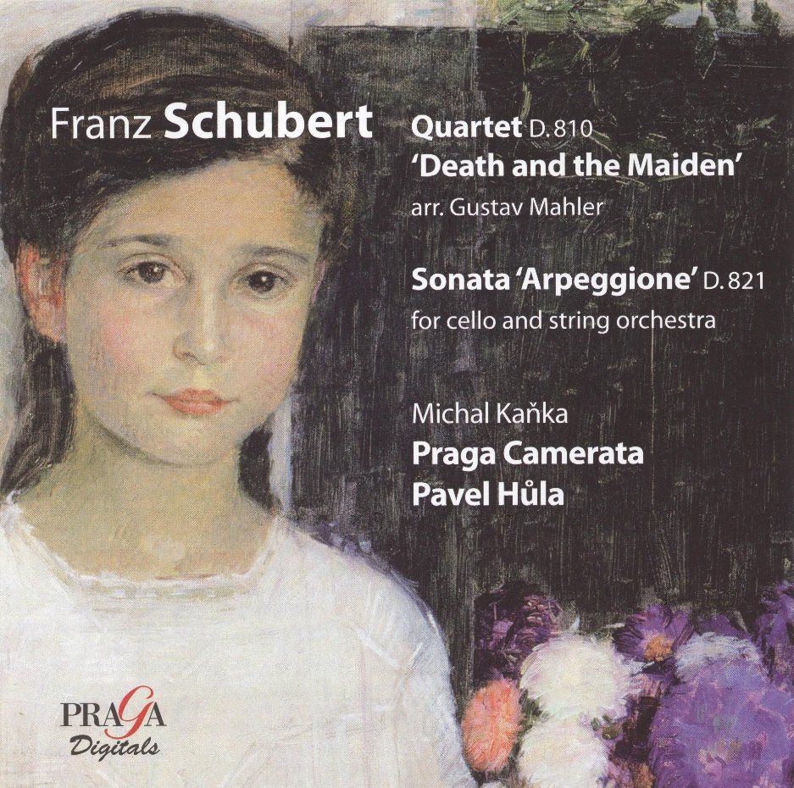

Формат записи/Источник записи: [SACD-R][OF]
Наличие водяных знаков: Нет
Год издания/переиздания диска: 2008
Издатель (лейбл): PRAGA Digitals
Жанр: Classical
Продолжительность: 01:06:44
Наличие сканов в содержимом раздачи: да
Треклист:
01 - Praga Camerata - String Quartet D.810 Death and the Maiden - I.Allegro - 15:44
02 - Praga Camerata - II.Andante con moto - 10:54
03 - Praga Camerata - III.Scherzo-Allegro moderato - 03:58
04 - Praga Camerata - IV.Presto - 09:40
05 - Michal Kanka-cello, Praga Camerata - Sonata D.821 Arpeggione - I.Allegro moderato - 12:25
06 - Michal Kanka-cello, Praga Camerata - II.Adagio - 04:17
07 - Michal Kanka-cello, Praga Camerata - III.Allegretto - 09:45

Personnel:
Michal Kanka - cello
Praga Camerata, Pavel Hula

Контейнер: ISO (*.iso)
Тип рипа: image
Разрядность: 64 (2,8 MHz/1 Bit)
Формат: DSD
Количество каналов: 2.0, 5.1
Original Recording Format: DSD64
Источник (релизер): WEB.
SA-CD.net - Schubert: Death and the Maiden, Arpeggione - Kanka, Praga Camerata, Hula

Доп. информация:
Label: PRAGA Digitals
PRD/DSD 250 246
Release Date: January 8, 2008
Original Recording Format: DSD64
Recording Type & Bit Rate: DSD64

Об альбоме (сборнике)
Two arrangements: one, undertaken by Gustav Mahler and revealed in 1984, of the most famous of Schubert’s 15 quartets, ‘Death and the Maiden’, of which he completed only the second movement Andante, which he in fact conducted in concert. Nowadays, such an expansion charms like the transfer of Schönberg’s Verklärte Nacht or Berg’s Lyric Suite to orchestra; the other, attempted many times, finally achieves a soloist-orchestra balance that preserves the Arpeggione‘s divertissement nature. Gaspar Cassadó proposed a version for large symphony orchestra that is somewhat overwhelming in relation to the simplicity of the original text. The present version for cello and strings, of which this is the first recording, offers a viewpoint both concertante and da camera that shows the purity, fraternal élan and timeless character of the cello’s melody to best advantage.
Reviews:
Comment by Gilbert Burnett - February 13, 2016
This is a lovely disc. The excellent DSD recording does full justice to some really beautiful string playing. It is worthy of a full review.

5.0 out of 5 stars The Best of Them All!
Reviewed in the United States on June 12, 2017
There are quite a few recordings of the iconic "Death and the Maiden". For SACD fans, you should definitely consider this Praga performance to be superior. The MCH recording quality is quite good. The positioning of the different voices in a call-and-response arrangement also makes for a more interesting recording as well. You can find several performances on You-Tube, so judge for yourself. Do me a favor...be sure to listen to this performance before jumping to purchase the recent release of this piece on Audite SACD by the Mandelring Quartet. Mandelring is a bit restrained in the performance - and the usual excellent Audite MCH recording seems to be far-miked and lacks sonic "punch" as well.

5.0 out of 5 stars A real high-end recording & topmost musical performance
Reviewed in the United States on February 3, 2018
Tekrad is right, this is a fabulous version!
Schubert's quartet is wonderful.
I have listened to Quartetto Italiano, Amadeus, Juillard, Alban Berg, Melos, Vermeer, Heath quartets.
(+Brandis Quartet in Schubert Brilliant classics edition).
All very nice.
This particular SACD version provides with a high-quality performance.
Both interpretation and technical performance are delightful.
I strongly recommend.

