Amsterdam Sinfonietta Soloists - Schubert: String Quintet in C (2015) [SACD]
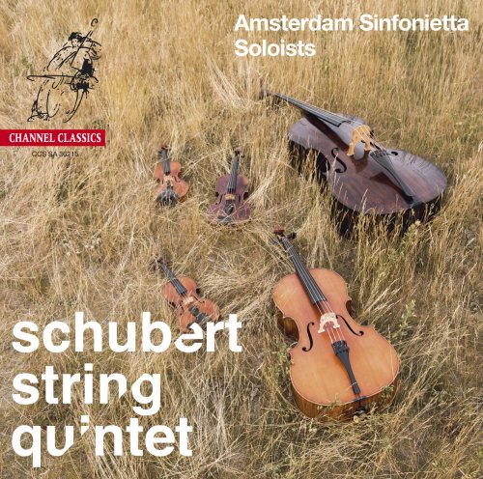
Artist: Amsterdam Sinfonietta
Title: Schubert: String Quintet in C
Year Of Release: 2015
Label: Channel Classics [CCS SA 36215]
Genre: Classical
Quality: DSD64 image (*.iso) / 2.0 > 1-bit/2.8224 MHz
Original Recording Format: DSD 64
Total Time: 00:52:38
Total Size: 2,8 GB (+3%rec.)
WebSite: Schubert String Quintet - NativeDSD Music

One of the icons of chamber music, Schubert's celebrated String Quintet is heard in an unusual version on this recording. Schubert's work was styled after those of Boccherini and Onslow, which featured two violins, viola and two cellos. After hearing the double bass virtuoso Domenico Dragonetti, Onslow decided to add an alternative bass part to replace the second cello part. Schubert might have done the same if he had heard Dragonetti play, so the Amsterdam Sinfonietta commissioned this Marijn van Prooijen adaptation, and the double bass part is performed here by Rick Stotijn.
Tracks:
01. String Quintet in C Major, D. 956, Op. posth. 163: Allegro ma non troppo
02. String Quintet in C Major, D. 956, Op. posth. 163: Adagio
03. String Quintet in C Major, D. 956, Op. posth. 163: Scherzo: Presto. Trio: Andante sostenuto
04. String Quintet in C Major, D. 956, Op. posth. 163: Finale: Allegretto

Info
A cathedral of tragic tones
‘The richest and most productive eighteen months in music history’ is how the English composer Benjamin Britten described Franz Schubert’s final period, when works including the magisterial String Quintet in C major saw the light of day. For besides the quintet, Die Winterreise (Winter Journey), the Symphony in C major (‘the Great’) and the last three piano sonatas flowed from Schubert’s pen. Since Beethoven’s death in 1827, Schubert was engrossed in the development of largescale musical forms, and certainly succeeded in this in the fifty minutes of the quintet. It is not the music of a man who knows he will die by the age of thirty-one, but music born of an almost volcanic ambition, comparable to that of Beethoven when he entrusted his string quartets opus 18 to paper. Notable is Schubert’s preference for a second cello, shared with Boccherini, rather than a second viola as in the quintets of Mozart and Beethoven. Although the four-movement plan of Schubert’s quintet is entirely in the classical tradition of his age, it is already quite clear from the first two movements that there is mention of a grand scheme, as they slowly unfold to reveal a large-scale structure not unlike the later symphonic cathedrals of Anton Bruckner (who was four years old at the time).
Composed in September and October 1828, the String Quintet in C major was Schubert’s instrumental swan song. In September he had taken up lodgings at his brother’s house in the Viennese suburb of Wieden. Thus new life was breathed into domestic music making in the family circle, as quartets and piano sonatas were played and songs were sung. As ever, Schubert was at the very centre, sitting at the grand piano or playing the viola in the quartets, and it was probably this that sparked off composition of the quintet.

Press reviews
Audio Review
(…) the instruments blend well, don’t overwhelm the others and have clarity, edge and depth (…)

Het Parool Magazine
The version by the Amsterdam Sinfonietta Soloists is special: instead of two cellos, they do it with cello and double bass, which provides extra depth and more drama. They play it beautifully.

Sachsische Zeitung CD-Tipp
(...) tragic depth and symphonic force (...) a tremendously suggestive interpretation of this exceptional work (...)
De Volkskrant5 out of 5
Immediately at the opening of Schubert's String Quintet, played by the solo strings of Amsterdam Sinfonietta, you will be amazed by the great contrasts between total stillness and drama, and the color palette that ranges from ethereal to deeply buzzing bass tones. (…)

The Guardian4 out of 5
(…) The playing is terrific: tasteful phrasing, gracious ensemble intuition and a string sound that’s luminous and poised.

Het Parool4 out of 5
Emotional depths (…) Schubert was never able to hear his String Quintet in C. You would grant him this performance, by five soloists from Amsterdam Sinfonietta. With a slender tone, the mildly floating vibrato and the transparency, the strings know exactly how to gauge the depth of Schubert's instrumental swan song. The second cello part has been adapted to Rick Stotijn's double bass. When he doesn't strings but strums, it sometimes seems as if small timpani are involved, as harbingers of death.

Opus Klassiek
were. (…) the recording quality is more than beautiful (…)

