Tchaikovsky - Symphony No.4 in F Minor, Op.36 & Romeo and Juliet Overture
Budapest Festival Orchestra, Ivan Fischer

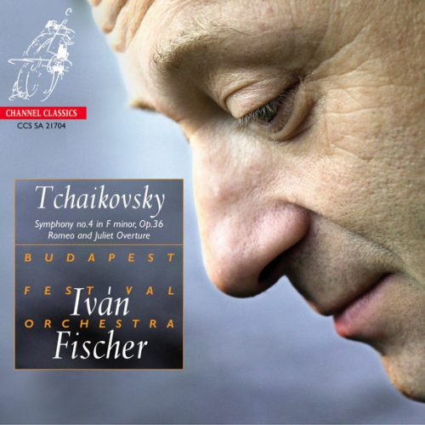

Формат записи/Источник записи: [SACD-R][OF]
Наличие водяных знаков: Нет
Год издания/переиздания диска: 2014
Издатель (лейбл): Channel Classics
Жанр: Classical
Продолжительность: 01:01:13
Наличие сканов в содержимом раздачи: да
Треклист:
1. Symphony No.4 in F Minor, Op.36 - Andante Sostenuto - Moderato Con Anima - 18:25
2. Symphony No.4 in F Minor, Op.36 - Andantino in Modo Di Canzana - 09:54
3. Symphony No.4 in F Minor, Op.36 - Scherzo; Pizzicato Ostinato - Allegro - 05:35
4. Symphony No.4 in F Minor, Op.36 – Finale - Allegro Con Fuoco - 08:22
5. Romeo and Juliet Overture - 18:57

Personnel:
Budapest Festival Orchestra
Ivan Fischer - conductor

Контейнер: ISO (*.iso)
Тип рипа: image
Разрядность: 64 (2,8 MHz/1 Bit)
Формат: DSD
Количество каналов: 2.0
Original Recording Format: DSD64
Источник (релизер): WEB.
Tchaikovsky - Symphony No. 4 In F Minor, Op. 36 & Romeo And Juliet Overture - NativeDSD Music

Доп. информация:
Label: Channel Classics
SKU 21704
Release Date: January 12, 2014
Recording location: Italian Institute, Budapest, Hungary, 11-14 February, 2004
Original Recording Format: DSD64
Recording Type & Bit Rate: DSD64

Об альбоме (сборнике)
One of the most wondrous friendships in musical history was the one between Pyotr Ilyitch Tchaikovski and a rich noblewoman, Nadjezhda von Meck. She worshipped Tchaikovski from afar and initiated a correspondence which, over the years, would amount to some 1200 letters. Madame Von Meck became Tchaikovskis patroness and granted him a generous yearly allowance. In this way it became possible for Pyotr Ilyitch to resign his detested job as a professor at the Moscow Conservatory, concentrate on composing, and travel, preferably abroad. The two agreed that they would never meet, in order to avoid any emotional complications which might arise. Thanks to the extensive correspondence, we are well informed about numerous details of Tchaikovskis life, including the background to his Fourth Symphony in f, op. 36, from 1877. Around this time, Tchaikovski had unexpectedly rushed into a marriage in order to avoid revealing his homosexuality. After a week with his bride, the composer suffered a nervous breakdown and made an attempt at suicide, after which the marriage was dissolved on medical advice. It was against this backdrop that the Fourth Symphony was composed…

Reviews:
Klassik Heute. com
Fischer allows music to be made lean, direct, very differentiated, with great expressiveness, dynamically wide, but always subtle, never general and never gaudy.

www.kwadratuur
Fischer shows the listener exactly when and what to listen to, thanks to a perfect balance of tempo, instrumentation or articulation. This gives Tchaikovsky's fourth symphony a nice shape and makes a listen neither strenuous nor tedious. For those who are not yet familiar with this revolutionary orchestra from Budapest, this CD is a wonderful introduction. Fischer gracefully plays on a whole range of emotions, does not avoid the theatrical, the dramatic, and thus delivers a fantastic record. Highly recommended!

Crescendo
At the head of his Budapest Festival orchestra, Ivn Fischer models every detail without mannerism, without ostentation, but with a constant desire to add a subjective element to its reading. The same hallucination runs through the Pome symphonique, Romo et Juliette. Beneath our ears, the lovers of Vrone live out their passion in all the horror of the Shakespearean drama.

Le Soir
Ivan Fischer knows how to extract inimitable sounds from his Budapest Festival Orchestra. A sound that has body, nervousness, which flatters the note, sustains a rhythm without ever becoming noisy. Including in the most shattering tutti that Tchaikovsky has the art of dislodging in his Romeo and Juliet and his 4th symphony. With, in addition, a silky tenderness of the strings, a vivacity of the winds, and, everywhere, the direction of the dance.

The Star-Ledger
Freshness is paramount with Fischer, and his players even make the sweeping soap opera tune of Tchaikovsky’s Romeo and Juliet sound novel. Fischer’s performance in the Fourth Symphony has a new-minted air … you’re going to revisit standard fare; this is the way to do it.

Fono Forum
With Fischer, Tchaikovsky appears again as a sensitive human vocalist and you can feel the closeness of the upper-class Russian salon with him. (...) Fischer discovers the polyglot European fine spirit and noble seeker of truth Tchaikovsky - and in this light of restrained passion his compositional mastery comes to the fore in all its sophistication.

Hi-Rez Highway
Connoisseurs of pure auditory sensation will not be disappointed. Definitely worth a listen.

Classics Today 5 out of 5
It’ll probably be the first time in years you’ve heard this warhorse without being bored to tears, despite the bombast. Playing by the Budapest Festival Orchestra is very high-caliber, particularly the brass. I’ll give it a 10/10 for the daring vitality and freshness of Fischer’s interpretation.

Audiophile Audition 5 out of 5
I have awarded this fine disc five stars because it is simply an exemplary SACD offering, delighting in the music it contains and consistently gratifying in its splendid sonics.

Gramophone
Fischer has enough that is meaningful and individual to justify a secure place among top digital recommendations.

Evening Standard 5 out of 5
Ivan Fischers Budapest Festival Orchestra has acquired a reputation as one of Europes finest and most individual. Warmly recommended, even if you already have these works in your collection.

International Record Review
Fischer makes the best of the regional tone color of his winds and the agility of his divided violins.

