Stile Antico, Fretwork - Tune thy Musicke to thy Hart (2012) [SACD]
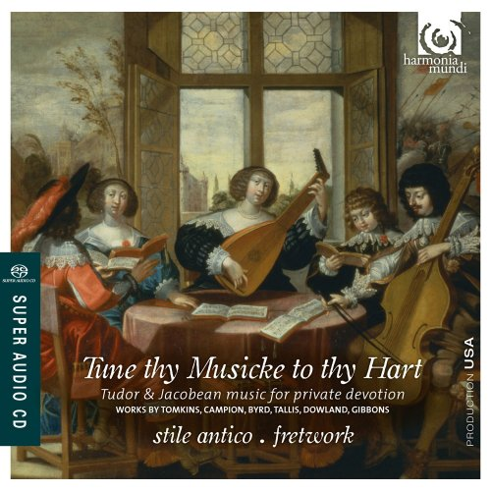

Artist: Stile Antico, Fretwork
Title: Tune thy Musicke to thy Hart
Year Of Release: 2012
Label: Harmonia Mundi ‎[HMU 807554]
Genre: Classical
Quality: DSD64 image (*.iso) - 2.8224 MHz
Recorded, edited & mastered in DSD
- Engineer [Recording], Edited By – Brad Michel
- Producer – Robina Young

Number of channels: 2.0/5.0
Total Time: 01:04:42
Total Size: 3,2 GB (+3%rec.)
WebSite: https://www.discogs.com/Stile-Antico-Fretwork-Tune-Thy-Musicke-To-Thy-Hart/release/5241797

Tracks:
[1] Thomas Tomkins (1572-1656): O praise the Lord
[2] John Amner (?-1641): O ye little flock
[3] John Taverner (c.1490-1545): In nomine
[4] Robert Ramsey (1590-1644): How are the mighty fall'n
[5] Thomas Tallis (c.1505-1585): Purge me, O Lord
[6] John Amner: A stranger here
[7] Robert Parsons (c.1530-1570): In nomine a 4 no. 1
[8] John Browne (fl.1480-1505): Jesu, mercy, how may this be?
[9] Robert Parsons: In nomine a 4 no. 2
[10] Giovanni Croce (c.1557-1609): From profound centre of my heart
[11] John Dowland (1562/63-1626): I shame at my unworthiness
[12] Thomas Campion (c.1567-1619): Never weather-beaten sail
[13] William Byrd (c.1540-1623): Why do I use my paper, ink and pen?
[14] Thomas Tomkins: When David heard
[15] Orlando Gibbons (1583-1625): See, see, the Word is incarnate

Info:
Stile Antico is an early music vocal ensemble consisting of 12 singers who perform without a conductor. It has focused largely on medieval and Renaissance-era sacred repertory, taking in music by Byrd, Tallis, Taverner, John Sheppard, and many anonymous works. Made up of three singers each in the soprano, alto, tenor, and bass ranges, the ensemble performs about 40 concerts yearly and regularly goes on tour. Twice nominated for Grammy Awards, Stile Antico has rightly earned the reputation as one of the finest smaller early music ensembles from the U.K.
Stile Antico was formed in Oxford, England, in 2001. Founding members, who were then mostly students, were sisters Helen (soprano), Kate (soprano), and Emma Ashby (alto), Carris Jones (alto), Eleanor Harries (alto), Andrew Griffiths (tenor), Oliver Hunt (bass), and Matthew O'Donovan (bass). All of them were still members in 2011 along with Rebecca Hickey (soprano), Jim Clements (tenor), Benedict Hymas (tenor), and Will Dawes (bass). The group has used as many as 16 singers.
Stile Antico's debut concert took place in Oxford, England, in 2001. For the first several years the group performed mostly on university holidays. Its breakthrough came when it entered the 2005 Early Music Network Young Artist Competition at the York Early Music Festival, where it won the audience prize. Robina Young, an executive for Harmonia Mundi, was on the competition jury and later signed the ensemble to a recording contract. In early 2007 its first recording, Music for Compline, was issued by Harmonia Mundi and went on to capture several prestigious awards, including a Diapason d'Or and a Grammy nomination.
In 2010 Stile Antico debuted to acclaim both at the Schleswig-Holstein Festival and at the BBC Proms. Among its more highly praised recordings is the 2010 Harmonia Mundi CD Puer natus est, a collection of Advent and Christmas works by Byrd, Tallis, Taverner, and others. Stile Antico made its Wigmore Hall debut in July 2011.
On recordings, the group has continued to focus mostly on Renaissance repertory, with original thematic conceptions such as From the Imperial Court: Music for the House of Hapsburg (2014); despite the tremendous importance of royal houses in the commissioning and use of music in the Renaissance, Stile Antico's album is one of few entries in this field. The group mounted a major "Shakespeare 400" tour, exploring the role of music in the Bard's plays. In performance, the group's repertory has ventured into the modern era. It has given premieres of music by Huw Watkins, John McCabe, and Nico Muhly (Gentle Sleep). The association with Muhly is significant, for Stile Antico's tour schedule has involved the U.S. to a notable degree; it made two visits to the U.S. during the 2016-2017 season alone, and, almost alone among ensembles from the classical sphere, has been featured on the popular Tiny Desk Concert video series posted by the National Public Radio network there. Stile Antico released a survey of the neglected music of Renaissance composer Giaches de Wert in early 2017.

Tune thy Musicke to thy Hart
For its sixth recording on Harmonia Mundi, Stile Antico is joined by the outstanding viol consort Fretwork to explore the wealth of sacred music written not for church performance, but for the court and for the home. Sung entirely in English, this fascinating programme spans two centuries and a vast range of styles, from the austerity of Browne and Taverner to the harmonic daring of Tomkins and Ramsey, and from the smallest works by Campion and Dowland to the great verse anthems of Gibbons and Amner.

Review:
Tune Thy Musicke to Thy Hart Review by James Manheim
So strong is the perceived distinction between public sacred works and private secular ones during the Renaissance that the pieces here have been almost completely ignored, even though several of them are by the top rank of English composers. These are counterparts to the secular English madrigal: small polyphonic pieces in English for use in home devotional observances. Some, in fact, are very much simply sacred madrigals: Giovanni Croce's From profound centre of my heart (track 10) has a very madrigalian illustration of Psalm 130's "sad groans." Others are more like English-language motets, while Thomas Campion's Never weather-beaten sail is a deceptively simple work rooted in the older anthem style. One of the best features of this album is the presence of several fine examples of the instrumental In nomine in a context in which they make sense. These pieces formed a tradition lasting from John Taverner (whose iconic example is included here) up through at least Henry Purcell; each is based on a melody appearing at the words "in nomine Domini" in the Benedictus movement of a mass by Taverner. These pieces are usually sandwiched in among viol consort pieces, but they fit better with these intimate vocal works: they are, in a sense, pieces based on a tune everyone knew. It is easy to imagine the whole program being played by a nobleman's small consort of musicians, and the joining of two distinct groups, the vocalists of Stile Antico and the instrumentalists of Fretwork, is accomplished without a seam. Harmonia Mundi contributes sound that perfectly fits the quietly thoughtful mood. This is a must for serious collections of English Renaissance music.

