Mariss Jansons, Royal Concertgebouw Orchestra - Mussorgsky: Pictures At An Exhibition (2009) [SACD]

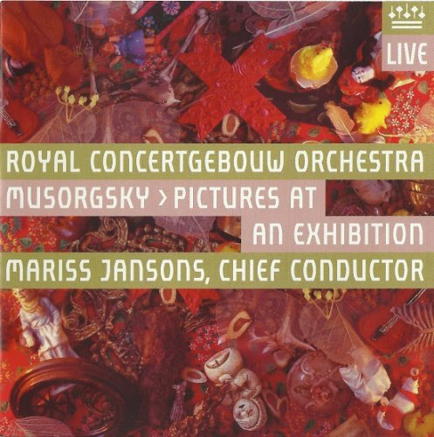

Artist: Mariss Jansons
Title: Mussorgsky: Pictures At An Exhibition
Year of Release: 2009
Recorded Live at the Concertgebouw Amsterdam on 22, 23 May and 29 August 2008
Label: RCO live [RCO 09004]
Genre: Classical
Quality: DSD64 image (*.iso)
DSD Recorded
Number of channels: 2.0/5.0
Total Time: 00:33:34
Total Size: 1,8 GB
WebSite: https://www.discogs.com/Royal-Concertgebouw-Orchestra-Musorgsky-Mariss-Jansons-Pictures-At-An-Exhibition/release/8697796
HRAudio.net - Mussorgsky: Pictures at an Exhibition - Jansons

Tracks:
01 Promenade 1:38
02 Gnomus 2:48
03 Promenade 0:59
04 Il vecchio castello 4:27
05 Promenade 0:31
06 Tuileries 1:05
07 Bydlo 2:46
08 Promenade 0:46
09 Ballet des poussins dans leurs coques 1:14
10 Samuel Goldenberg und Schmuyle 2:33
11 Limoges, le marchй 1:23
12 Catacombae, sepulchrum Romanum 2:09
13 Cum mortuis in lingua mortua 2:05
14 La cabane sur des pattes de poule 3:28
15 Le grande porte de Kiev 5:09
Personnel:
Royal Concertgebouw Orchestra
Mariss Jansons (conductor)

Info:
In this day & age, a compact disc with a playing time of 33:02 is more than a tad short, but what is here is stunning: an account of Ravel’s orchestration of Mussorgsky’s Pictures at an Exhibition that reveals the grandeur of the music in a performance of tremendous vitality & a recording of stupendous immediacy. Mariss Jansons finds things in this well-known score that most conductors miss — details of articulation, phrasing & balance that often go unnoted — & brings out the work’s enormous variety of forms, moods, & colors. The Royal Concertgebouw Orchestra of Amsterdam plays with its accustomed super virtuosity, reveling in overcoming the score’s prodigious challenges with effortless panache. RCO Live’s super audio recording captures everything in sound that puts the listener in the Concertgebouw about 10 rows back from the stage. But, really, only 33:02? Why not more Ravel or more Mussorgsky, a bit of Borodin or a slice of Stravinsky? What’s here is inestimable, but it leaves the listener eager for more.
Reviews:
Review by willemvoorneveld July 18, 2012 (13 of 19 found this review helpful)
Performance: 5 Sonics: 5
Ok, another “Pictures at an exhibition” was not where we were waiting for (How many of them do we already have) unless there are special reasons to release one. On top of that this disc only provides 33 minutes of music, so all in all this sets high expectations.
And after listening I found at least 3 compelling reasons to buy this disc as quickly as possible.
First, Mariss Jansons sheds some new light on the score; he avoids cheap effects and keeps the heavy orchestrated parts 12 up to 15 very transparent. For the first time I can hear what is happening in those heavy orchestrated sections.
Second reason is that the RCO show off their enormous capabilities. Woodwind, important in any Ravel score, is a dream and the orchestra as a whole is playing very coherent and articulates very sharp.
And last but not least the DSD recording reveals all this beauty effortless. Low frequency rumble is very clean and clear and the violins have a realistic tone as never before. How much better can it get? Very good in stereo also!
This disc would do well as a Sales-promotion present for every SACD high end sale but more important it is artistically very satisfying as well.
Willem

Review by boxer_ian September 30, 2012 (5 of 10 found this review helpful)
Performance: 5 Sonics: 5
I can't thank you guys enough for all your reviews. You have introduced me to recordings I would never have discovered on my own, and this is another one. For an old rock and roller who was introduced to this piece by E,L &P and wondered from where this music came, then I this is the source. Rich, dynamic and all engrossing. SACD at it best. Thank you.

